Step 1: Access E-Travel Worklist via email:

From the Email sent by PeopleSoft Finance to the Primary Approver, click the hyperlink on bottom to go to Worklist.

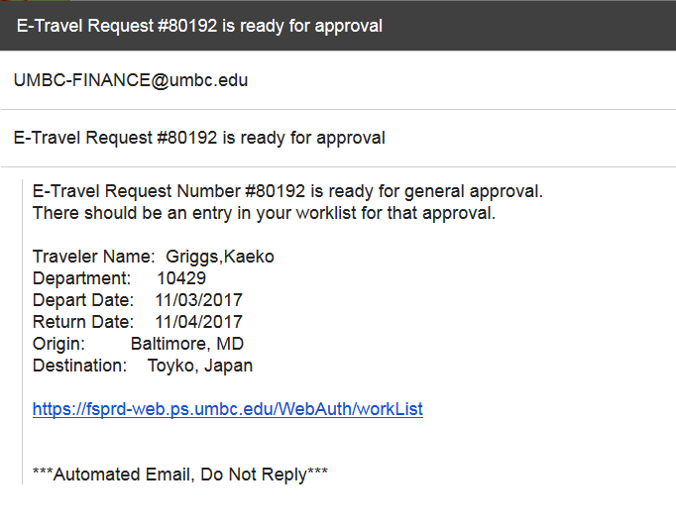

Alternate Step 1: Alternative way to Access E-Travel Worklist:
From PeopleSoft Finance, click on the Worklist hyperlink in the upper right corner to bring up the E-Travel Worklist.

Step 2: From E-Travel Worklist Screen:

Click on the hyperlink for the Travel Request Number for the traveler. Their legal name is displayed, because it is used on official Travel Documentation.

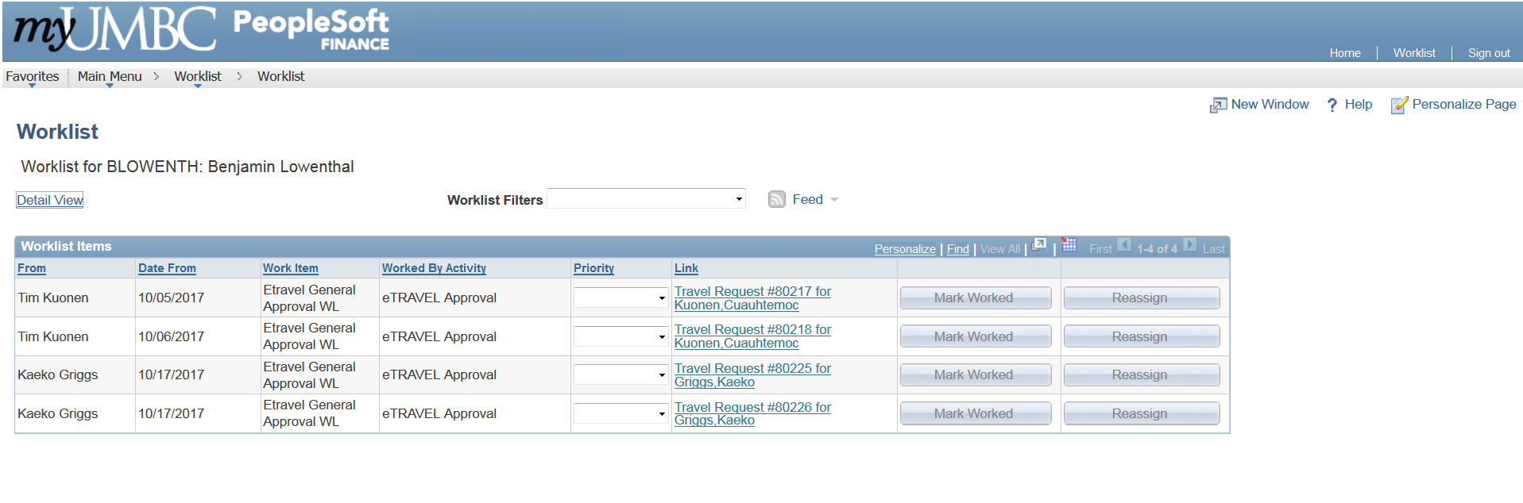

Step 3: From Travel Request Approval Screen:
Change the drop down for “Approval Action” to Deny.
Comments are required for Denied Travel, so to traveler or person entering travel can take appropriate action.
Click SAVE Button shown on next page.
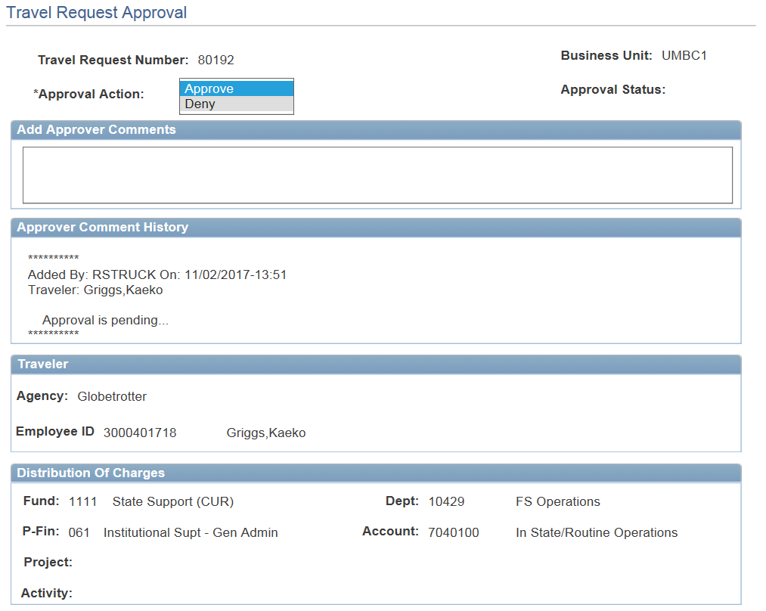

As soon as the Primary Approver or one of the other E-Travel Approvers DENY the travel, the request will drop off everyone’s Worklist.

Sample Email for Denied Travel:
Email is sent to Traveler and person entering travel.

