Step 1: Access E-Travel Worklist via email:

From the Email sent by PeopleSoft Finance to the Primary Approver, click the hyperlink on bottom to go to Worklist.

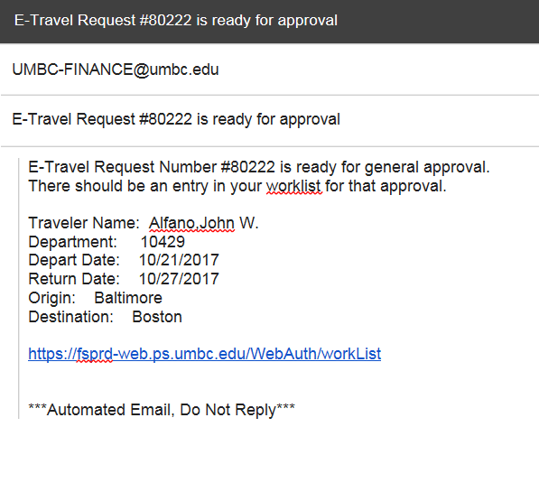

Alternate Step 1: Alternative way to Access E-Travel Worklist:
From PeopleSoft Finance, click on the Worklist hyperlink in the upper right corner to bring up the E-Travel Worklist.

Step 2: From E-Travel Worklist Screen:

Click on the hyperlink for the Travel Request Number for the traveler. Their legal name is displayed, because it is used on official Travel Documentation.

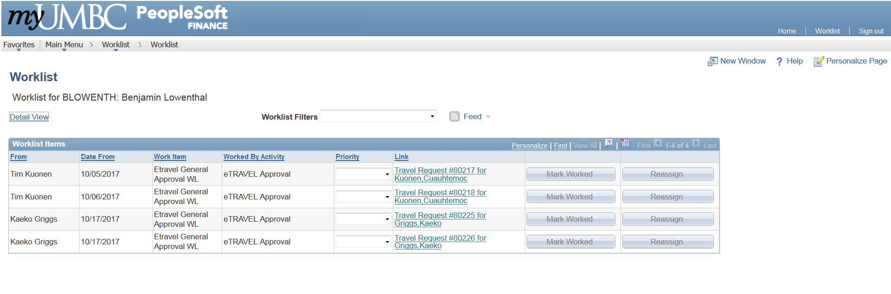

Step 3: From Travel Request Approval Screen:
The drop down for “*Approval Action” defaults to Approve. As an approver, please scroll down the page ensuring that sections have accurate information. If it is approved, please click SAVE Button shown on next page.

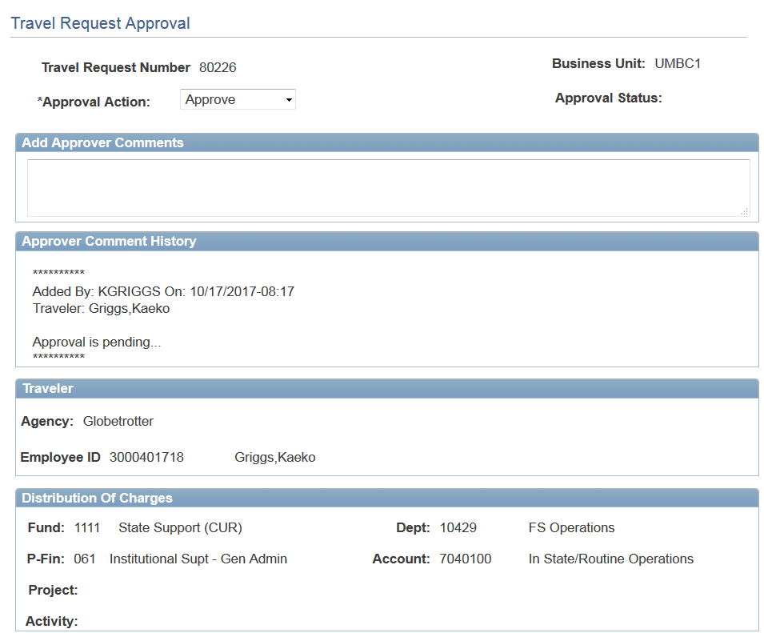
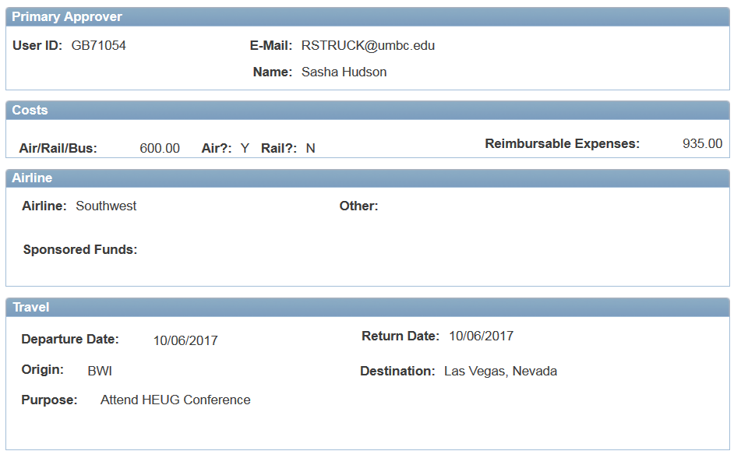
All E-Travel Approvers for the department will have the E-Travel request in their PeopleSoft Worklist, but only Primary Approver will receive email immediately. As soon as the Primary Approver or one of the other E-Travel Approvers approve the travel, the request will drop off everyone’s Worklist. The reminder email to approve travel will be sent after 24-48 hours to all Approvers for a department.

If needed Step 3A: Foreign or Past Date Approver: From the Email sent by PeopleSoft Finance to the Foreign or Past Date Approver, click the hyperlink on bottom to go to Worklist. As of Dec. 1, 2017, if the Primary Approver ALSO is a Foreign Approver for the department, then Step3A-3C are accomplished with the initial Approval.
Any E-Travel request that has the Foreign Account selected will require additional approvals from the next higher authority, unless the next higher authority is the person that was selected as the Primary Approver. Also, any E-Travel request that has a past date will also be sent.
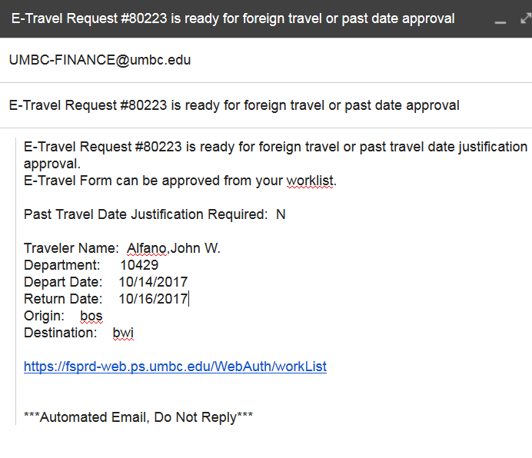

If needed, Step 3B: From E-Travel Worklist Screen (Foreign or Past Date):
Click on the hyperlink for the Travel Request Number for the traveler.
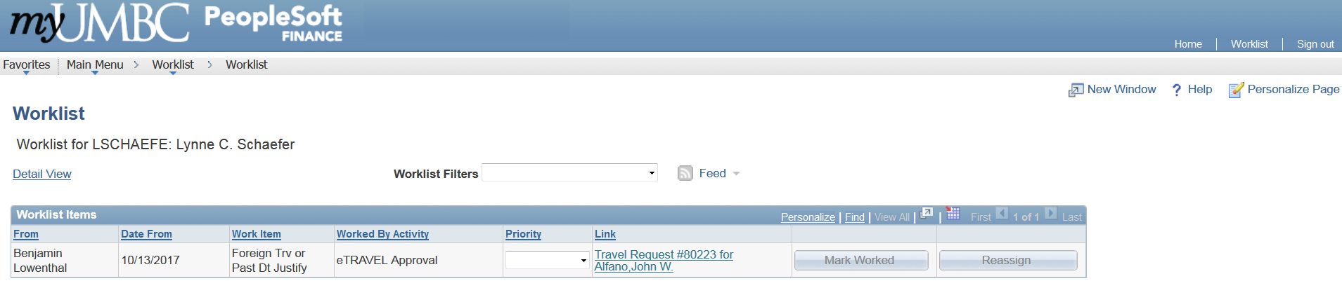

If needed, Step 3C: From Travel Request Approval Screen. Same screen as Step 3, with an additional view of the Primary Approver’s Comment History. Click SAVE Button on bottom of page to Approve.

Step 4: Travel Department Approving Authority
The Travel Dept. receives the approved E-Travel after it has been approved by all Department Approving Authorities.
If tickets need to be issued by one of our contracted agencies, an AGENCY must be selected. If the wrong agency is selected or if “Other” was selected in error, a Supplemental E-Travel will need to be completed and approved prior to tickets being issued by the Travel Dept.

