## **Purchase Order Invoices in PAW**

Note: If receipt(s) not already created and you have received the product/service, follow the instructions for creating Quantity Receipts or Cost Receipts for your goods/services before creating an invoice.

To create an invoice against a PAW purchase order, first you must search for and pull up your purchase order. There are numerous ways in which to search for a PO (or any document) in PAW.

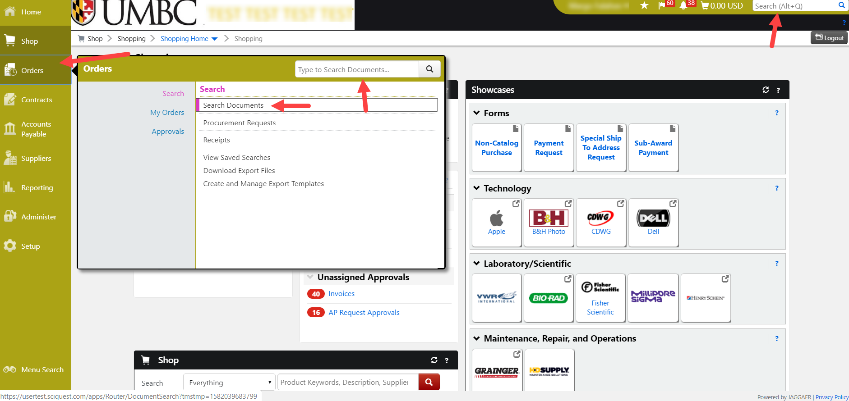

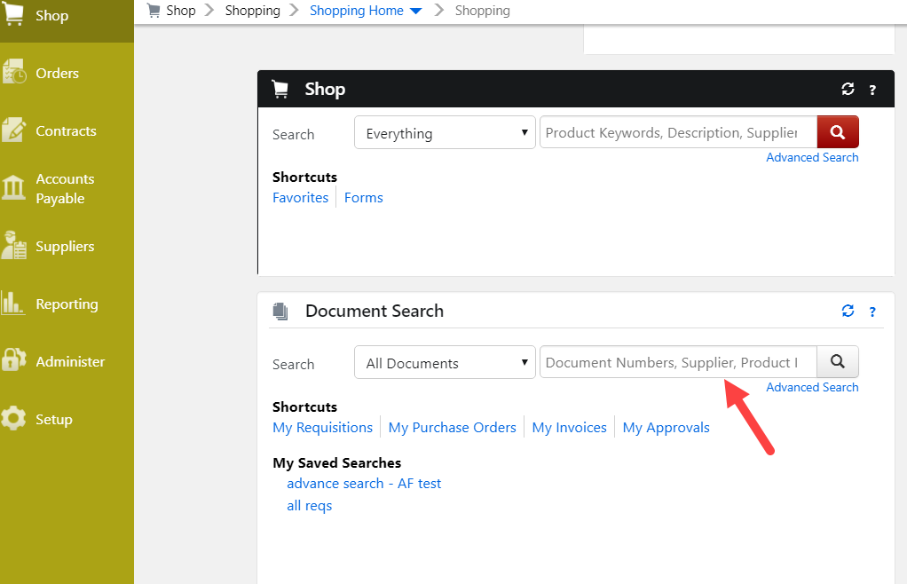

Once your PO is displayed, click on DOCUMENT ACTIONS then click on CREATE INVOICE

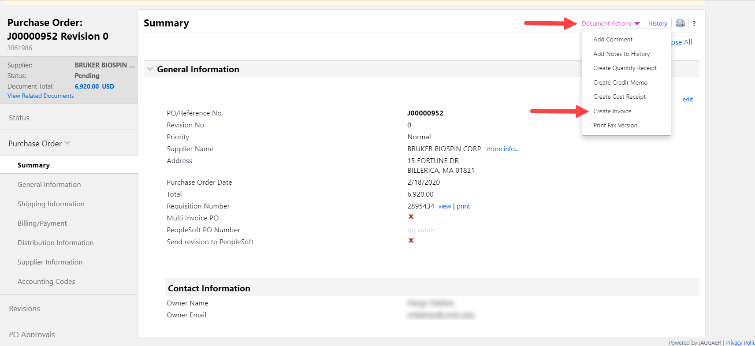

Displayed will be a Simple Manual Entry page where you will enter:

* Invoice Date
* Invoice Number

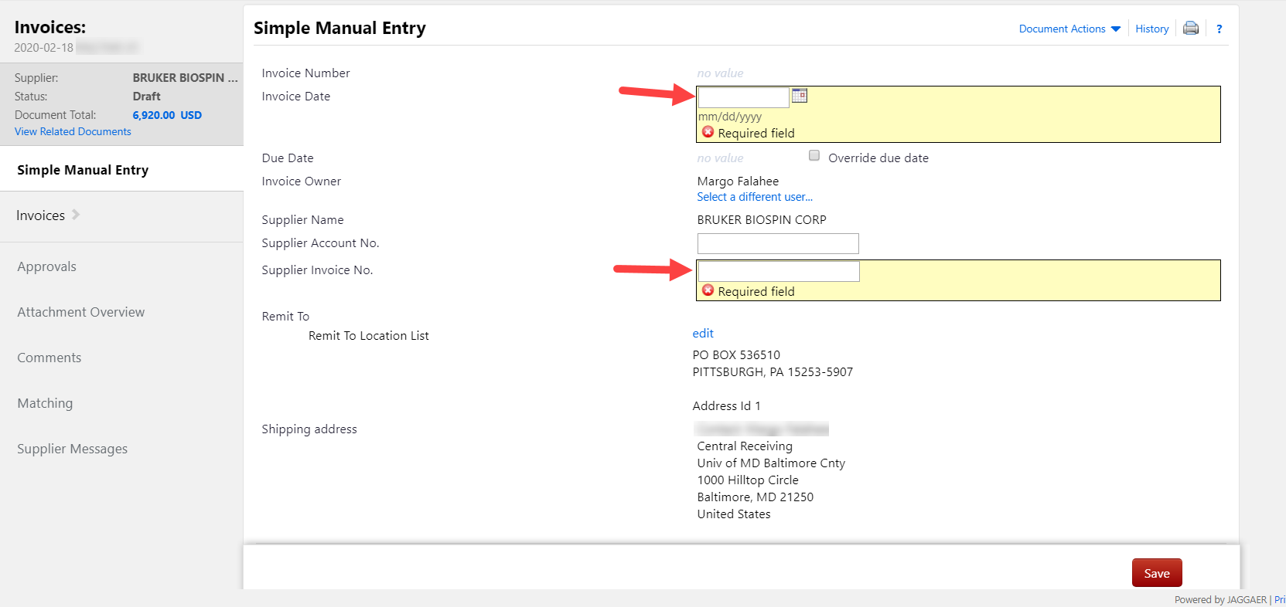

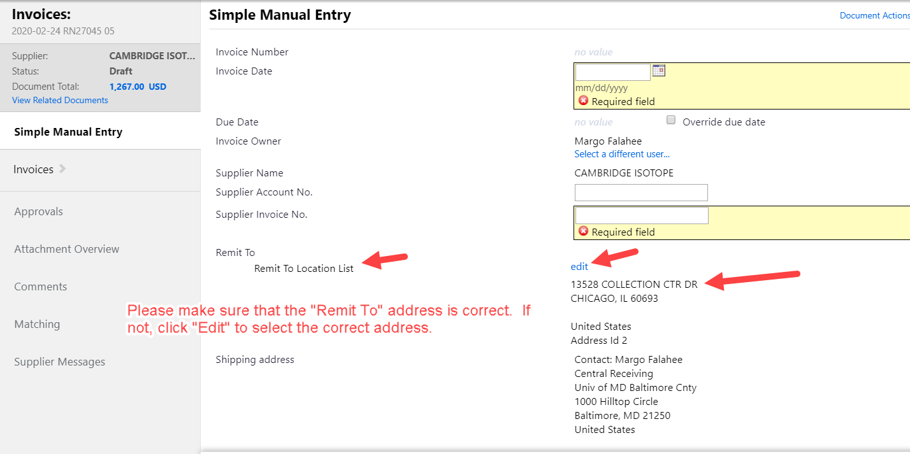

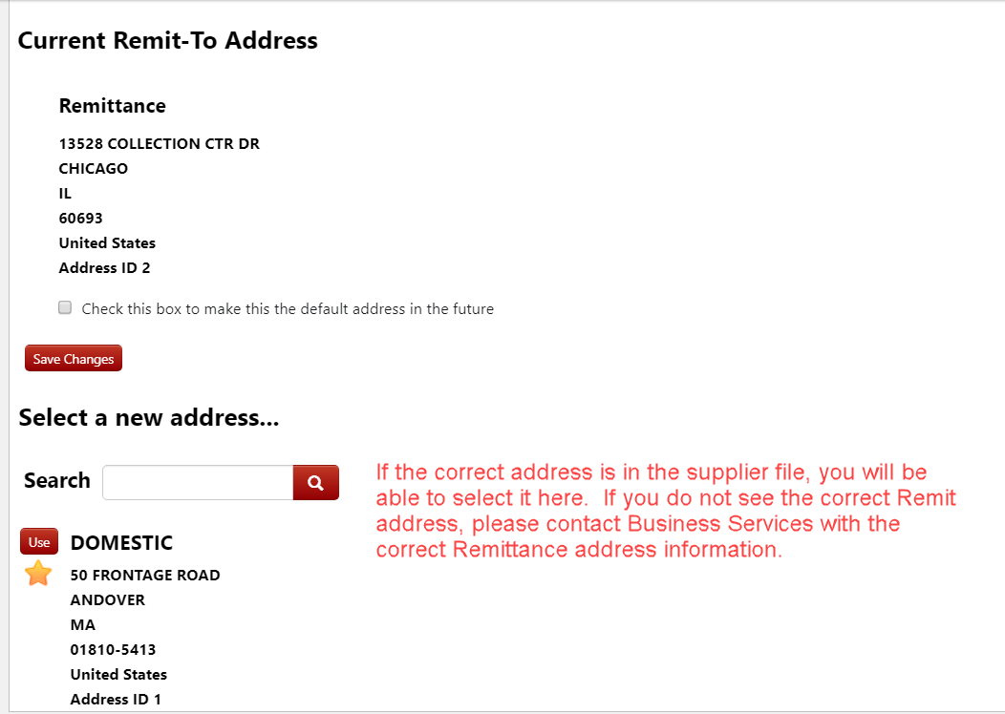

* If the invoice is not for the full amount of the PO, make the necessary changes to the invoice entry lines to match the supplier’s invoice.

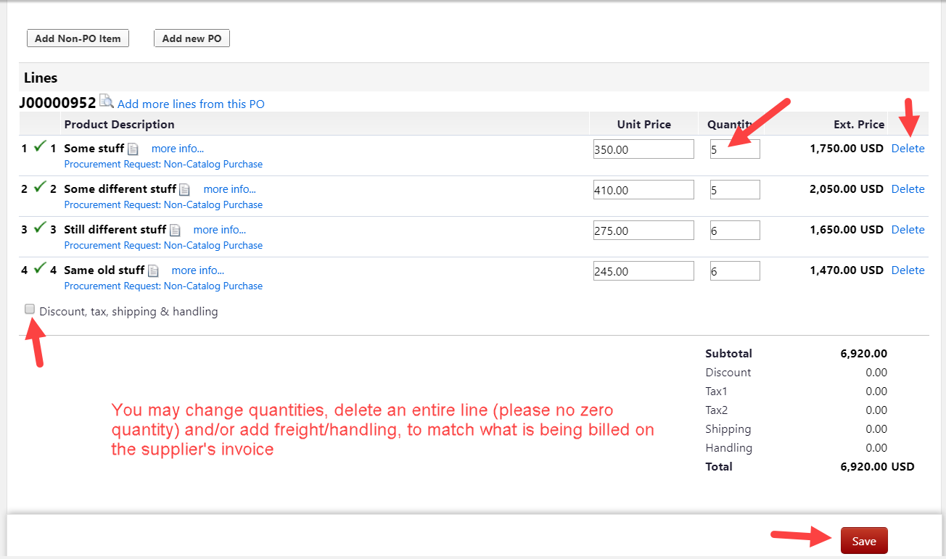

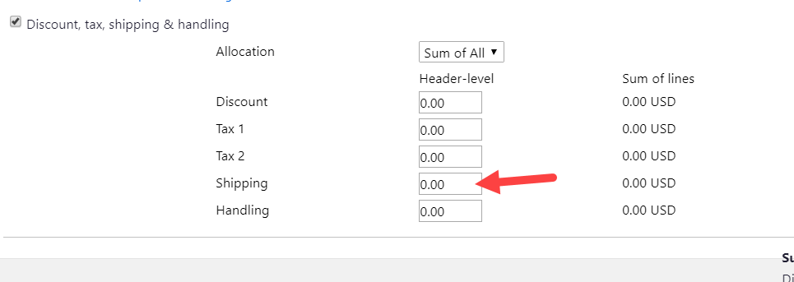

Once you are finished adding and/or changing information, click SAVE.

The last step in the process is attaching a scanned copy of the suppliers invoice. This can be done by using the NOTES/ATTACHMENTS link or the ATTACHMENTS OVERVIEW link

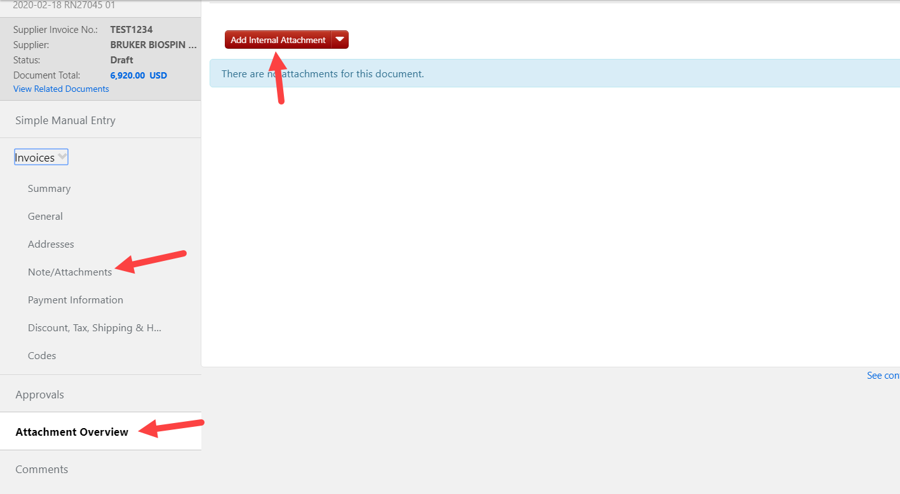

After you have completed this step, you may FINALIZE INVOICE.

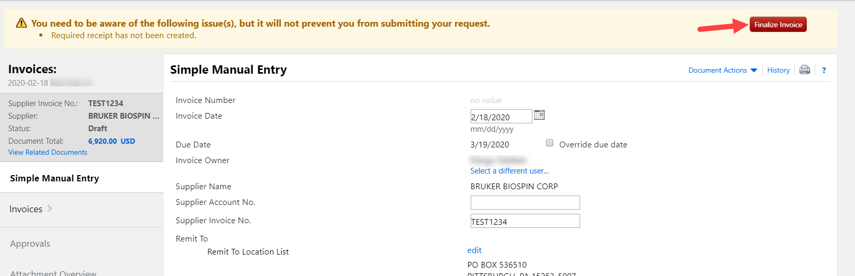

**Please note that the invoice will not be processed for payment without a receipt created against the purchase order. You may find instructions on Receipt Creation on Procurement’s website or by clicking the available link.