TRAVEL SYSTEM FAQs
Travel Landing Page
Refer to the UMBC Travel Policy
The Role of the UMBC Travel System
Additional Resources
Travel System Profile
Authorize Others to Submit Travel Requests on Your Behalf
List of Users That Have Authorized You to Submit Travel on Their Behalf
Removal
PRE-APPROVAL
Why do I need to fill out a Pre-Approval before I travel?
When do I need to complete a Pre-Approval?
Who has access to the UMBC Travel System?
Is there a limit on the travel duration for Pre-Approval requests?
Can I submit a travel request for a person who is not currently affiliated with UMBC (interview candidate, visiting speaker, etc.)?
What are the steps to creating a Travel Pre-Approval Request?
Who is traveling?
Enter Title and Travel Date Range (Mandatory Fields)
Trip Title
Click “Create Pre-Approval”
DETAILS for the Pre-Approval
The Traveler’s Mailing Address:
Trip Title and Travel Dates
Start Address
Destination Address(s)
Travel Agency
At the time the travel agent approves the ticket request, he/she will enter the price of the ticket and upload the travel itinerary. Docusign will notify the traveler/preparer with the approval and the itinerary.
Purpose
Is Travel Federally Sponsored?
Are You Requesting a Working Fund Advance?
Will Any Portion of the expenses be covered by non-UMBC funds?
ESTIMATES for the Pre-Approval:
Summary
Distribution of Charges
Transportation
Lodging/Food
Per Diem
Fees/Misc
DOCUMENTS
COMMUNICATIONS
SUBMIT FOR REVIEW
SUBMIT TO DOCUSIGN
REVIEWERS
“TAKING” or “Assigning” a Travel Pre-Approval for Review
“UNTAKING” a Travel Pre-Approval
“REASSIGNING” a Travel Pre-Approval
Can I “TAKE” a Travel Pre-Approval for Review that is already assigned to someone else?
Travel System Roles
REIMBURSEMENT
Transportation
Summary
Distribution of Charges
SUBMIT FOR REVIEW
SUBMIT TO DOCUSIGN
Other questions you may have…
Status Codes

UMBC TRAVEL SYSTEM

Travel Landing Page

Refer to the UMBC Travel Policy
A comprehensive explanation of all policies and procedures for UMBC related travel.. You will be required to acknowledge your acceptance and compliance of these policies during the Pre-Approval process.

The Role of the UMBC Travel System
The Travel System is an online system used to facilitate the travel process at UMBC. It supports the policies and procedures with a method to obtain the necessary authorization prior to travel and also submit travel related expenses for Reimbursement when travel is complete.

The boxes shaded in blue are part of UMBC Travel System processing. Note that State of Maryland processing for expense reimbursement is external to UMBC.

Additional Resources
Submit a Travel Inquiry
To submit a travel-related help ticket, use the link above, or quick-link it from within the travel system using the “Useful Links” dropdown in the upper right corner of the screen.

Travel System User Profile
Each user has a profile that may be accessed by clicking the “Actions” dropdown box in the upper right corner of the screen and choosing “Go to Admin.”

If you are new to the system, the action will say “Go to Profile.”

Authorize Others to Submit Travel Requests on Your Behalf
In the Admin section of the dashboard, there are a number of buttons: Profile, Departments, People, Per Diems, Role Names and Status Codes, depending on your role. If you have no role assigned in the system, you will only have the Profile button.

Use the “profile” options to identify those individuals that are authorized to submit travel requests on your behalf. Enter the campus ID or Empl ID for the individual you choose to authorize on your behalf and click “add”. You can use the directory lookup to find the campus ID. A quick link to the directory is located in the upper right hand corner of the Travel System Screen.

List of Users That Have Authorized You to Submit Travel on Their Behalf
The bottom half of the profile screen provides a list of all UMBC Travel System users that have authorized you to submit travel requests on their behalf.

Removal
To remove access from users that were previously authorized to submit travel on your behalf, simply click on the “x” to the left of their name under the “remove” column.
You may remove yourself from the list of users that have been authorized to submit on behalf of another traveler, using the same process.

You can return to the Main part of the Travel System page by clicking on the “Action” dropdown box in the upper right corner and clicking “Go the Main.”

PRE-APPROVAL
UMBC Travel Pre-Approval Process
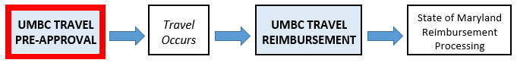

Why do I need to fill out a Pre-Approval before I travel?
The UMBC Travel Pre-Approval secures travel details, estimated expenses, approval for travel and departmental budget approvals. Automated communication and transactions will occur with travel reviewers, approvers, UMBC finance personnel, UMBC approved travel agencies, and the UMBC International Travel Registry.

When do I need to complete a Pre-Approval?
Refer to the UMBC Travel Policy for an explanation of travel Pre-Approval requirements and conditions. Generally, all out-of-state and/or overnight travel will require pre-authorization.

Who has access to the UMBC Travel System?
UMBC faculty, staff and student workers are able to access the travel system. The travel system uses UMBC Single Sign On (SSO) technology.

Is there a limit on the travel duration for Pre-Approval requests?
The start/end dates for the UMBC Travel Pre-Approval must match the start/end dates for the UMBC Travel Reimbursement request.

For example, if your travel is authorized for a 14 day trip, you must wait until your return to submit a 14 day Reimbursement claim. You cannot submit weekly Reimbursement claims in this scenario.

Can I submit a travel request for a person who is not currently affiliated with UMBC (interview candidate, visiting speaker, etc.)?
Travel for Non-UMBC Affiliates will require a UMBC sponsor with access to the travel system.

As one of the first steps to begin the Travel Pre-Approval process, you will be prompted to identify who is traveling - yourself, somebody who has pre-authorized you to prepare a travel request on their behalf (See Travel System Profile Link), or a Non-UMBC Traveler. Upon selecting Non-UMBC traveler in the drop-down box, you will be prompted for additional information (see screenshot below):

It is essential that the full legal name is entered here for reimbursement purposes and airline tickets.

A valid and correct email address for the traveler will be required to communicate with the traveler during the docusign process.

If the traveler has a prior history of travel with UMBC, it is likely that they are already in the UMBC system with an existing Reimbursement ID. The Office of Financial Services has lookup capabilities in this scenario, and the number should be entered here to speed up the reimbursement process.

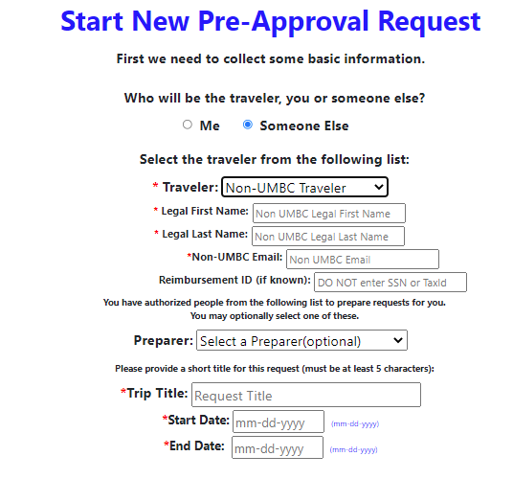

CREATE a Pre-Approval
What are the steps to creating a Travel Pre-Approval Request?

To begin the Travel Pre-Approval Process, click on the green “Create Pre-Approval Button” from the main screen

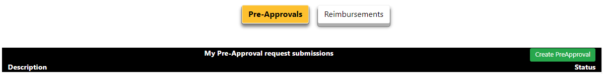

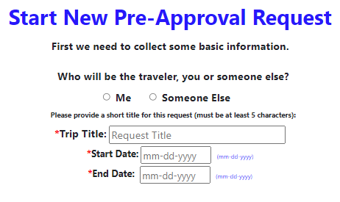

Who is traveling?
Select the appropriate radio button to identify whether you are the traveler, or completing the travel request on behalf of an individual that has granted you permission to do so.

If you are completing this request on behalf of another traveler, that traveler must grant prior permission using their profile options. (See Travel System Profile Link). Select their name from the dropdown list. You will be listed as the preparer.

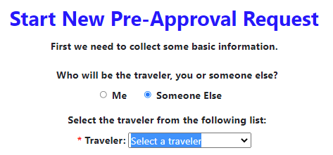

Enter Title and Travel Date Range (Mandatory Fields)
- Enter a meaningful Title/Label for this travel item. A title is mandatory.
- Enter the start and end dates for this travel event. Dates must be later than the current date.

Trip Title
Enter a name for this trip that is meaningful to you. Each trip is assigned a unique ID number, but this is a way to easily identify your travel by name.

Click “Create Pre-Approval”
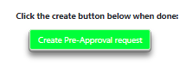

DETAILS for the Pre-Approval

The Traveler’s Mailing Address:

This address is stored differently than other addresses you may have on file for Human Resources or Student Records. This is used by the State of Maryland for processing payments that are not related to payroll and other UMBC purposes. It is sometimes referred to as a “vendor address”. In this case, the traver is considered a “vendor” by the State of Maryland as it issues a payment to cover travel expenses through the reimbursement process.

If an address is retrieved and displayed here, be sure that the address is correct and complete before continuing.

If no address is on file, or the displayed address is incorrect, follow the prompts to correct/enter the address and submit to Financial Services.

Please note that an address must be on file before the reimbursement process can proceed. Correcting existing entries and/or entering a new address here will prevent a reimbursement delay.
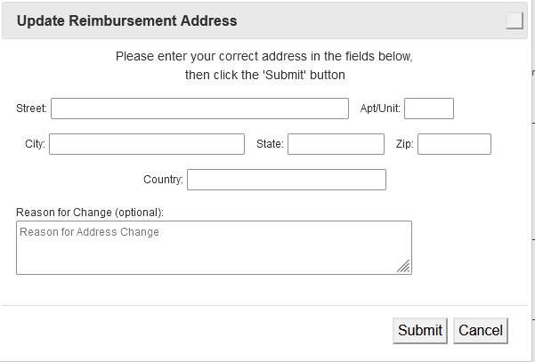

An RT ticket number will display upon submission of an address entry or correction, and will be forwarded to Financial Services for data entry. When complete, the RT ticket will be closed. In the rare instance of multiple address changes occurring in a short period of time, existing RT change requests must be complete before new address changes can be submitted.

If a travel request is submitted on behalf of a non-UMBC affiliate, this address is critical for reimbursement via check, as there is no opportunity for the state to transfer funds electronically.

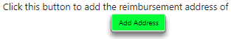

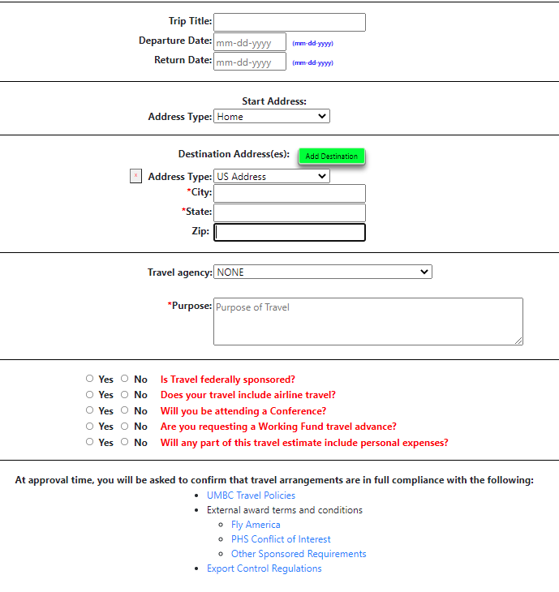

Trip Title and Travel Dates
The fields will reflect the information you entered during the creation of the Pre-Approval. You may change these fields at any time prior to submitting the Pre-Approval for “REVIEW”. Use the drop down menu on the right side of the screen to “save” changes.

Start Address
Select the appropriate address type for your travel start location, which indicates where you are beginning your travel for cost purposes. If the start address is not your home or UMBC, the city and state fields are mandatory.
- Home
- UMBC
- US Address
- Other Country Address

Destination Address(s)
You may have one or more destinations for a single travel request. Use the “Add Destination” button if you have multiple destinations. For each destination, select the address type and address details. If the destination is not your home or UMBC, the city and state fields are mandatory. The destination or destinations is/are required along with the explanation of the travel purpose to indicate where to and for what purpose the traveler is traveling.

- Home
- UMBC
- US Address
- Other Country Address

Travel Agency
If you will use a UMBC authorized travel agency to arrange for air or rail travel, select the appropriate agency from the drop down list. You, or the person preparing travel on your behalf, must contact the agency and obtain an informal quote.

You will be prompted to provide the estimated ticket cost and a check box acknowledging that you have contacted the agency.

Upon gaining all appropriate sign-offs for Travel Pre-Approval, the travel agency will then be contacted automatically (using DocuSign). The travel agent will enter the actual ticket cost at this time.
If the actual ticket cost entered is in excess of 10% or $200 (whichever is greater) over the quoted estimate for budget approval, the request will be denied and will return to “entry” status for re-approval at the higher quoted price.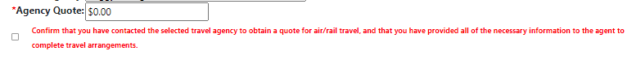

At the time the travel agent approves the ticket request, he/she will enter the price of the ticket and upload the travel itinerary. Docusign will notify the traveler/preparer with the approval and the itinerary.

Please note: the UMBC travel staff will no longer be communicating with the travel agency on behalf of the traveler. All questions regarding the travel tickets are to be directed to the travel agent.

Purpose
Enter the reason for travel.

Is Travel Federally Sponsored?
Select “yes” if your travel costs are federally sponsored. Refer to the UMBC travel policy, Contract and Grant Accounting Travel, and Federal Travel Regulations.

Are You Requesting a Working Fund Advance?
If you plan to request an advance for travel purposes from the UMBC Working Fund, select “yes”.

You will be prompted to acknowledge that you have reviewed associated policies and processes for Working Fund Travel Advances. The workflow for your travel request will include automated review, approval, and reimbursement processing through the UMBC Working Fund administrator.

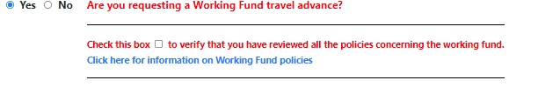

Will Any Portion of the expenses be covered by non-UMBC funds?
If your travel will include extra, personal expenses that are not easily separated from the travel estimates, please select “yes”.
Reference the UMBC Travel Policy for those expenses that are eligible to be covered/reimbursed.

Use the “Traveler Responsibility” field under the “ESTIMATES” → “SUMMARY” section to specify an amount for expenses you will be responsible for.

This amount will be deducted from the total expenses that are submitted for budget approval.

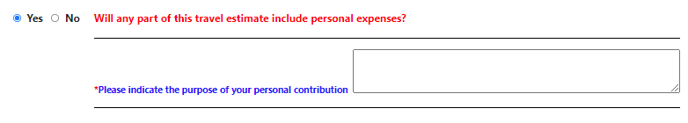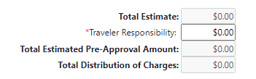

- Will any part of this travel include Athletic Recruitment?

Athletics is approved to use a specific travel agency and uses documentation specific to Athletics recruitment.

- Will the traveler be fully vaccinated for Covid-19 by the date the travel begins?

All travelers on University-related out-of-state travel are required to be fully vaccinated against COVID-19 by the start date of their travel unless appropriate waiver documentation is on file with the University.

If the traveler is not compliant with the policy and cannot answer yes to this question, the pre-approval cannot be submitted for approval.

ESTIMATES for the Pre-Approval:

Use this section to itemize estimated expenses. The Travel Pre-Approval is gathering estimated costs for budget authorization and approvals.

Expenses are broken down into 4 categories and will accommodate up to 5 different chartstrings (if expenses are to be split across multiple departments).

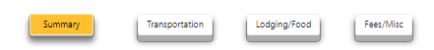

Summary
The summary page presents a recap of all estimated expenses entered under transportation, lodging/food and fees/misc. As itemized expenses are entered under each category, they will display on the summary page and total at the bottom under “Total Estimate”.

All estimated expenses must be accounted for under a valid budget account combination (distribution of charges, also known as a chartstring) before the Pre-Approval will move forward to DocuSign.
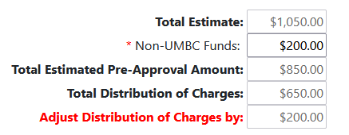

If Non-UMBC expenses are included, they will be deducted from the “Total Estimate” to calculate the Total Estimated Pre-Approval Amount.

The Total Estimated Pre-Approval Amount must be fully accounted for in the Total Distribution of Charges (using one department, or across multiple departments) before the Pre-Approval is submitted to DocuSign.

Adjust Distribution of Charges must equal $0, by adjusting the value on the chartstring line(s), or adjusting estimated expenses. The text on this line will change to red when the funding sources are inadequate to satisfy the Total Estimated Pre-Approval Amount.

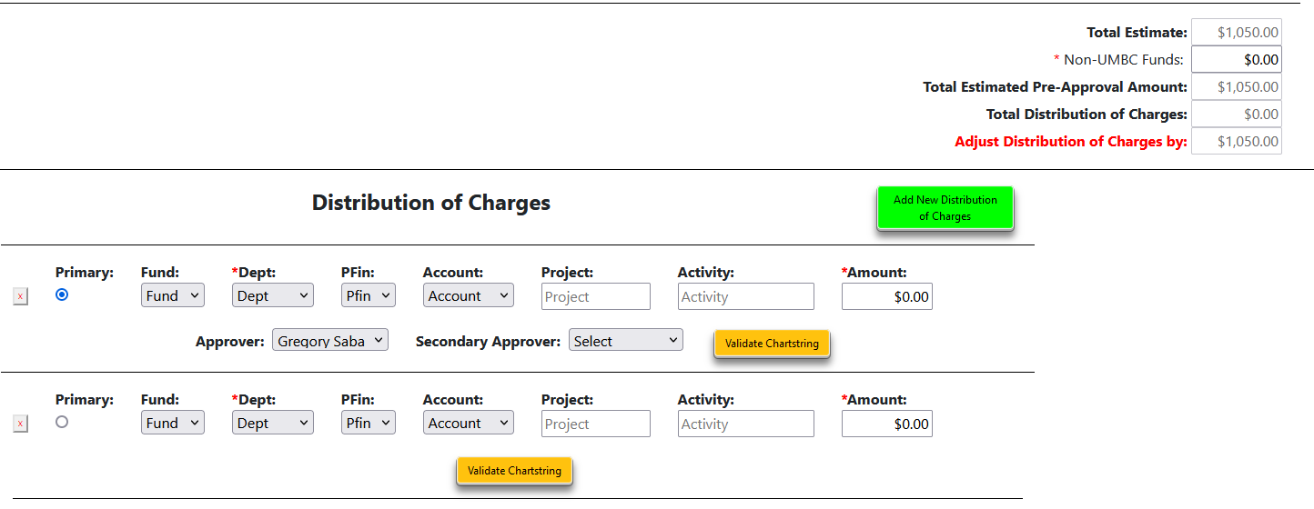

Distribution of Charges
Each chartstring has at least one “approver”, possibly a “second approver” if the department so chooses, and a “next higher authority” to approve international travel requests. Each approval level, for each department, must sign-off during the DocuSign process.

- Click “Add Distribution of Charges” to add multiple chartstring rows.
- Click the “x” to the left of the chartstring to remove a chartstring row.
- When there are multiple chartstrings, use the “Primary” button to select the primary account. Only ONE primary chartstring/account combination may be selected at any given time.

Each chartstring has an on demand “validate chartstring” button. Clicking this button will compare the selected account combination against valid PeopleSoft account combinations. Valid chartstring/account combinations are required before submitting to docusign for approvals.

Transportation
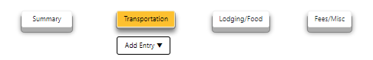

Transportation drop down options include:
- Plane
- Train
- Rental Car
- Ride Sharing
- Taxi/Bus
- Parking
- Tolls
- Other

Plane, Train and Taxi/Bus
Travel estimates require a date for travel, locations to and from (relevant to the travel type - city, airport code, actual address, etc.) and amount. Use the comment section to share additional information. For airline travel, please use the airport code for domestic airports and city/state if an airport code is not available for international airports.

Three-letter airport codes covering the United States can be found here.

If a round-trip ticket is a single cost item, use a single row to define “from/to” with the departure date from the drop down. If your tickets have costs broken down for each leg of the trip, and you want to use multiple rows to define the estimated costs, you have the ability to do so.

You cannot submit the Travel Pre-Approval with zero-cost rows.

Remember that the Travel Pre-Approval is gathering estimated costs for budget authorization and approvals.

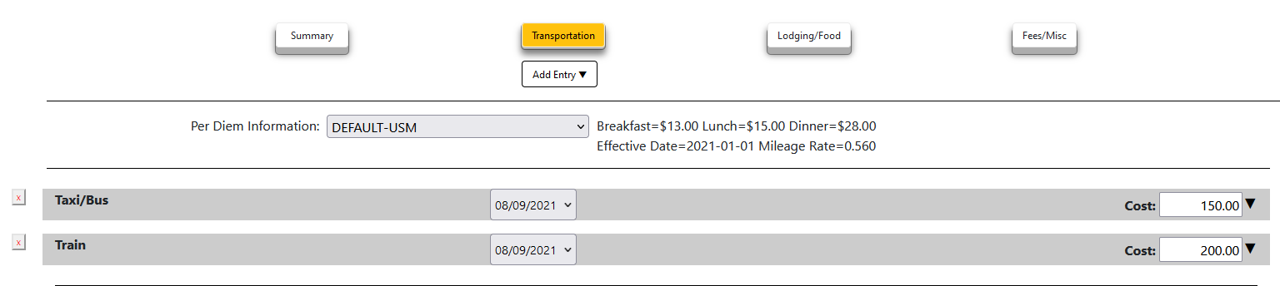

Rental Car, Ride Sharing, Parking, Tolls, Other
Travel estimates require an amount and also include a comment section to share additional information.

Personal Car Mileage
Use the “Other” category to estimate mileage and associated costs when using your personal vehicle. The mileage reimbursement rate is posted at the top of the screen.

Lodging/Food
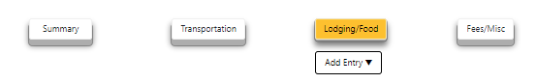

Lodging/Food drop down options include:
- Lodging
- Per Diem Meals
- Non Per Diem Meals
- Other

Use these options to estimate expenses related to lodging and food. You may use multiple rows to enter detailed expenses, or use a single row per category to estimate expenses at a high level.

Delete unwanted rows by selecting the “x” to the left of the row. You will be prompted to confirm before the delete action occurs.
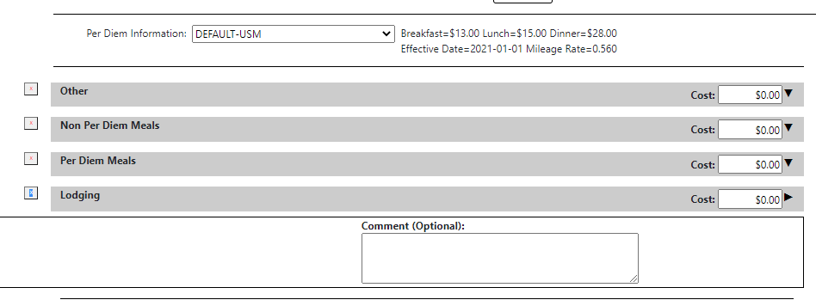

Per Diem

Qualified Per Diem meals do not require a receipt for reimbursement purposes. Use this section to estimate the cost for per diem meals during travel.

Default per diem rates are displayed at the top of the screen. To select a domestic high cost city with different per diem rates, use the drop-down list. Consult the UMBC travel policy for information related to international travel per diem rates.

Fees/Misc
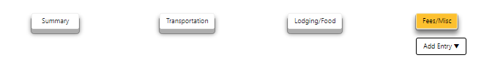

Fees/Misc drop down options include:
- Registration Fee
- Membership Fee
- Internet Fees
- Foreign Travel Visa Fees
- Materials
- Other

DOCUMENTS
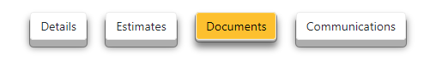

Upload receipts, conference materials necessary for reimbursement, hotel reservations and other documents that may be relevant to your travel and reimbursement needs.

Files uploaded here will be copied over to the reimbursement, but will also be archived with the Pre-Approval. These files will also be included with the DocuSign envelope during the approval process.

Click the “Choose File” button to select the file from your device.
Select a category for the file:
- Airfare
- Breakfast
- Lunch
- Dinner
- Lodging
- Car Rental
- Registration Fees
- Parking
- Tolls
- Other

Files may be added/deleted before the Travel Pre-Approval is Submitted to DocuSign. Once the Travel Pre-Approval request is submitted to docusign, all fields are locked and documents are preserved in the archive.

COMMUNICATIONS
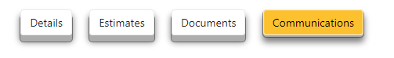
All communications/messages sent automatically from the travel system, or initiated manually from the travel system are available from the “Communications” tab.
Automated messages are generated from Travel Pre-Approval actions. Examples of actions include the creation of the Travel Pre-Approval Request, submitting for Review, Assignment Changes, Submitting to DocuSign, etc.

Use the “Show History”/”Hide History” button to toggle between showing all messages or hiding them. By default, they are suppressed. Most recent messages are displayed first. To see the content of the message, use the arrow on the right side of the row.
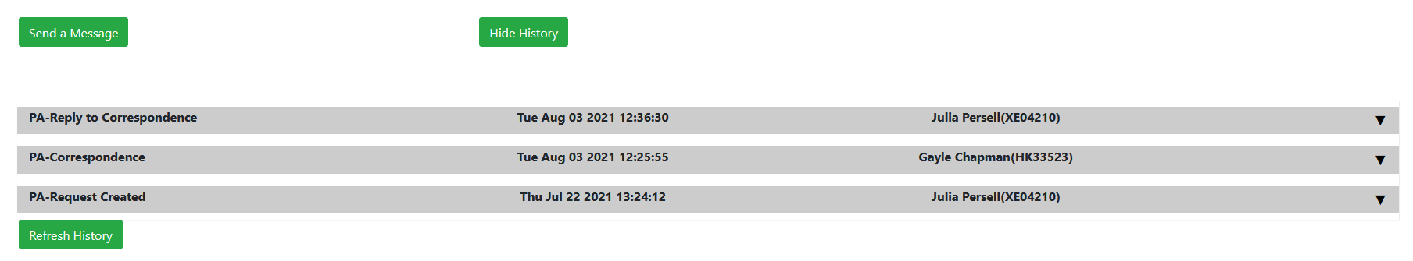
Select “Send a Message/Correspond” to initiate a message from the travel system. You can send a message to all persons included in the Travel Pre-Approval workflow, a subset of persons in the workflow, and a one time “CC” for persons that are outside of the workflow. Use the arrow keys to add/remove individuals from the message.

Type your message in the “Message” box and click “Submit” to send. Selecting “Cancel” will cancel the message and take you back to the main “Communication” screen.

Messages generated from within the travel system will be sent using UMBC email, and will also be archived with the Travel Pre-Approval.

The “sender” of the email message will be “Travel System via RT”
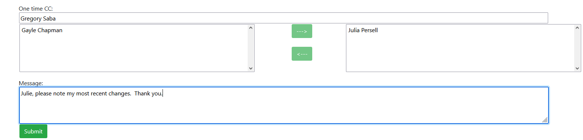

SUBMIT FOR REVIEW
When all mandatory fields are complete, the traveler/preparer may submit the Pre-Approval request for “REVIEW”. This action will send an email message to ALL persons with the PA-REVIEWER role in the department to notify them that the Pre-Approval has been submitted. (Only the Reviewer receives an email. If no PA-APPROVER is chosen, there will not be an email sent by the system.)
If the travel costs are shared among more than one department, the PA-REVIEWER(S) in the department designated as *primary* on the distribution of charges will receive the email message.

The status of the Travel Pre-Approval will change from “Entry” to “Review”.

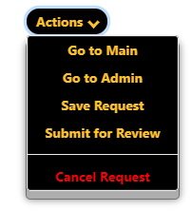

When the Travel Pre-Approval Request has been submitted for Review, and is in “Review Status”, the traveler is limited to the following actions:

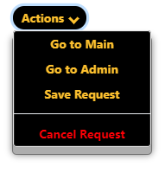
Changes to Pre-Approval details may occur during review.

SUBMIT TO DOCUSIGN
The Reviewer may submit the Travel Pre-Approval to DocuSign when the review is complete. At this point, no further changes can be made to the Travel Pre-Approval details.

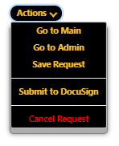
If no PA-REVIEWER is chosen for the department, the PA-APPROVER may submit to DocuSign.

After all of the signatures are completed, the Traveler and Approvers(s) will receive an email notification that the Pre-Approval is complete. The status on the Pre-Approval will change to “complete.”

REVIEWERS
The Pre-Approval Reviewer (PA-Reviewer) is usually someone identified by the department to review requests for completeness and accuracy. This can also be the Traveler if so inclined or there is no business staff identified to fill the PA-Reviewer role

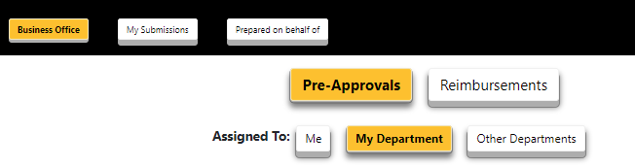

“TAKING” or “Assigning” a Travel Pre-Approval for Review
This action takes place in the Main section of the Pre-Approval Travel System by choosing “Business Office” and “My Department.” If you are a departmental reviewer, locate the travel item that you will “TAKE” for Review.

Select the travel item and navigate to the “Details” page.

Select your name, or another “Reviewer” from the “Assigned To:” drop down list.

“UNTAKING” a Travel Pre-Approval
If you have been assigned to review a Travel Pre-Approval, another reviewer cannot “TAKE” it from you. You must first “UNTAKE” the Pre-Approval to put it up for grabs, or “Assign” the Pre-Approval to someone else.

An assigned reviewer may “UNTAKE” a Travel Pre-Approval by using the “Assigned To:” dropdown and selecting “Nobody”. The following pop-up message will display. Click OK to “UNTAKE”, or cancel.

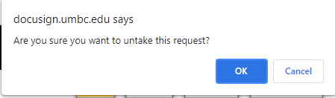

“REASSIGNING” a Travel Pre-Approval
If you have been assigned to review a Travel Pre-Approval, another reviewer cannot “TAKE” it from you. You must first “UNTAKE” the Pre-Approval to put it up for grabs, or “Assign” the Pre-Approval to someone else.

An assigned reviewer may “ASSIGN” a Travel Pre-Approval to another person by using the “Assigned To:” dropdown and selecting another Reviewer from the dropdown list. The following pop-up message will display. Click OK to “ASSIGN”, or cancel.

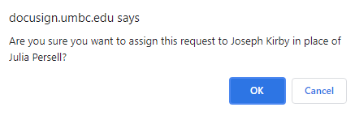

Can I “TAKE” a Travel Pre-Approval for Review that is already assigned to someone else?
No. The assigned person must UNTAKE or REASSIGN the Travel Pre-Approval.

Travel System Roles
There are a number of roles assigned in the Travel System that define the access and actions that can be taken. They revolve around three basic types after the traveler and preparer. There are two designation prefixes, which indicate the Pre-Approval part of the system or the Reimbursement part:
PA - Pre-Approval
RB - Reimbursement

PA-Reviewer, RB-Reviewer:
The PA-Reviewer and RB-Reviewer can be the same person or different people. The Reviewer is usually someone identified by the department to review requests for completeness and accuracy. This can also be the Traveler if so inclined or there is no business staff identified.

PA-Approver, RB-Approver
The PA-Approver and RB-Approver can be the same person or different people. The Approver can perform all tasks as a Reviewer, but is usually just included in the Pre-Approval/RB-Approval Routing step in DocuSign.

The Secondary Approver is an optional approver in the Approval Routing Step.

The Approver and Secondary Approver roles are requested through Financial Services at: https://financialservices.umbc.edu/9-2-departmental-approval-instructions/

The Next Higher Authority is required for any travel which is outside of the US. The RB-Next Higher Authority is required for any travel which is outside of the US, out of state or overnight travel without Pre-Approval.

Department Administrator
The Department Administrator (Dept Admin) role can manage the Reviewer and Next Higher Authority roles because they are optional, as well as the Dept Admin role. The Dept Admin can review all Travel System settings in addition to managing the three roles. This role can also re-assign the Assign-To person on either a Pre-Approval OR a Reimbursement request while in a Review status.

REIMBURSEMENT
UMBC Travel Reimbursement Process
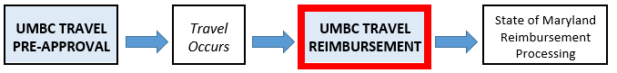

When do I create a UMBC Travel Reimbursement?
The traveler must have a completed and approved Pre-Approval before the travel begins, when the trip is out of state or involves overnight travel within state (Maryland and DC are both considered in state for UMBC travelers). Conversely, a Pre-Approval is not required when the traveler makes a day trip within the state.

The traveler or preparer for the traveler requests a Travel Reimbursement once travel is completed within ten days of the return.

How do I create a UMBC Travel Reimbursement
The traveler or a preparer for the travel (See Travel System Profile Link), can begin the reimbursement process by navigating to the Main Section of the Travel System and choosing “Reimbursements”, then “Create Reimbursement” on the right.

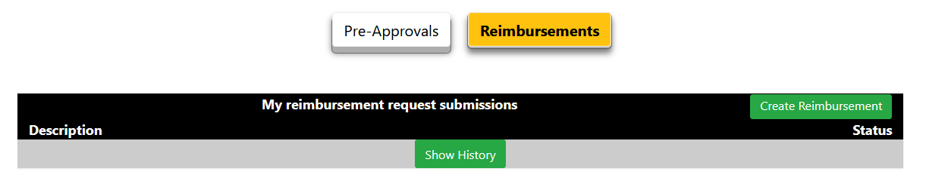
The system will ask if you have a Pre-Approval.

If you indicate Yes, it will retrieve your list of approved Pre-Approval requests to choose from. You can then choose from your list of Pre-Approvals and choose “create reimbursement.”

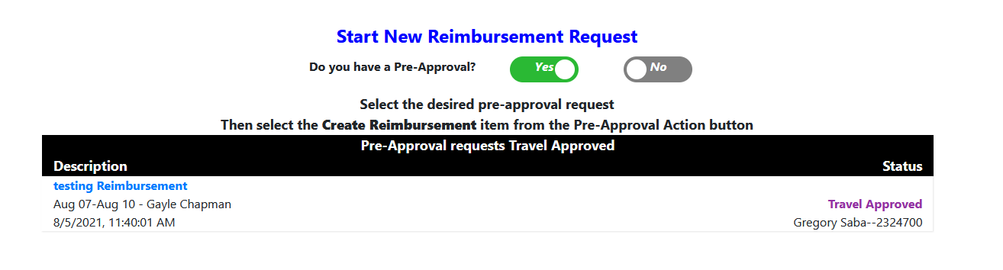
If you indicate No, it will ask you if the travel involved an overnight stay and whether the traveler went out of state.

If the travel involved an overnight stay or the traveler went out of state, the system will return the answer that the reimbursement request required a travel pre-approval and to proceed with the reimbursement, a memo of explanation is required, and that the request will automatically route to the next higher authority for approval. It will continue by requesting the information that would have been collected during the pre-approval process.

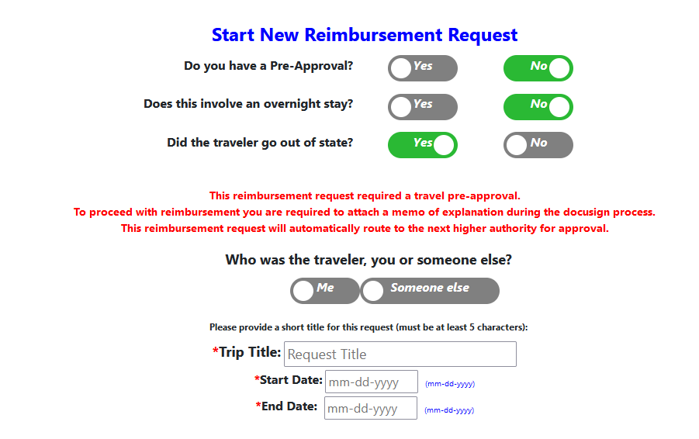
If the travel did not involve going out of state, nor overnight, the reimbursement will proceed with no message.

Reimbursement Request with Completed Pre-Approval
The information from the Details and Estimates sections of a completed and approved pre-approval is brought over to the reimbursement request. Both pre-approval and reimbursement have the same Travel ID. The pre-approval or reimbursement information is located in the upper left hand corner, depending on whether you are in the Pre-Approval or Reimbursement sections.
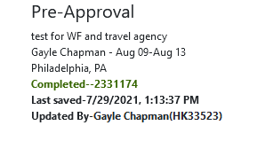

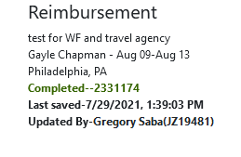

Completing a Reimbursement Request
Completing a Reimbursement Request is similar to completing a Pre-Approval. The system will bring over the data from the Pre-Approval, and the information brought over will be in grey.

The reimbursement Expenses, Documents and Communications sections are very similar to the Pre-Approval section, with a few exceptions.

Expenses
While the estimates brought over from the Pre-Approval will show in grey, you can replace the estimate with the actual cost. Be sure that your support documentation for the costs are legible and the dates and the amounts match.

Transportation

Transportation drop down options include:
- Plane
- Train
- Rental Car
- Ride Sharing
- Taxi/Bus
- Parking
- Tolls
- Other

Plane, Train and Taxi/Bus
Travel costs require a date for travel, locations to and from (relevant to the travel type - city, airport code, actual address, etc.) and amount. Use the comment section to share additional information. For airline travel, please use the airport code for domestic airports and city/state if an airport code is not available for international airports.

Three-letter airport codes covering the United States can be found here.

If a round-trip ticket is a single cost item, use a single row to define “from/to” with the departure date from the drop down. If your tickets have costs broken down for each leg of the trip, and you want to use multiple rows to define the costs, you have the ability to do so.

Lodging/Food

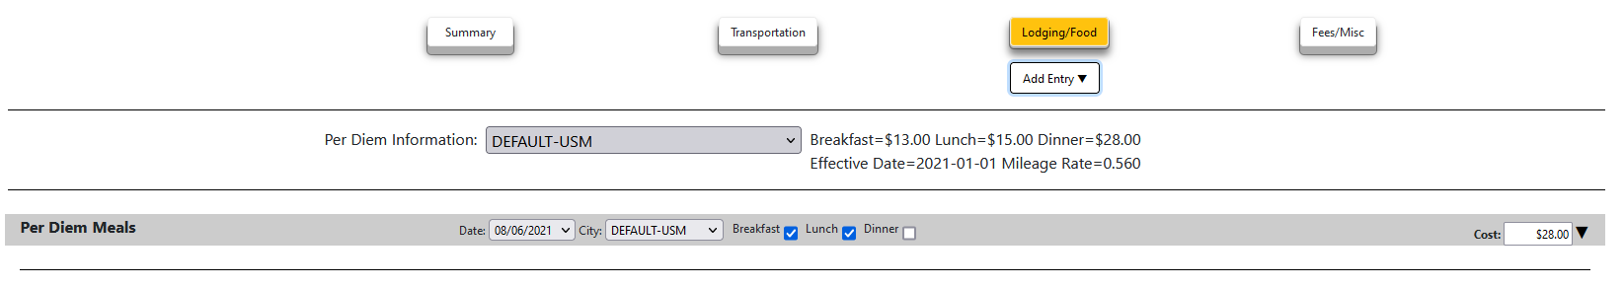
In this section, you can choose from the following drop down menu options:
- Lodging
- Per diem meals
- Non per diem meals
- Per diem meals - Foreign
- Other
The domestic per diem meal rates are provided for you. The default per diem rates are the regular rates for locations that are not considered high cost areas. However, you can choose the high cost cities by state/city in the Per Diem Information drop down menu for the per diem rates for that city.

For foreign per diem rates, you can choose that option in the “Useful Links” on the top right hand corner of the page, which will take you to the appropriate website with that information by the U.S. Department of State.

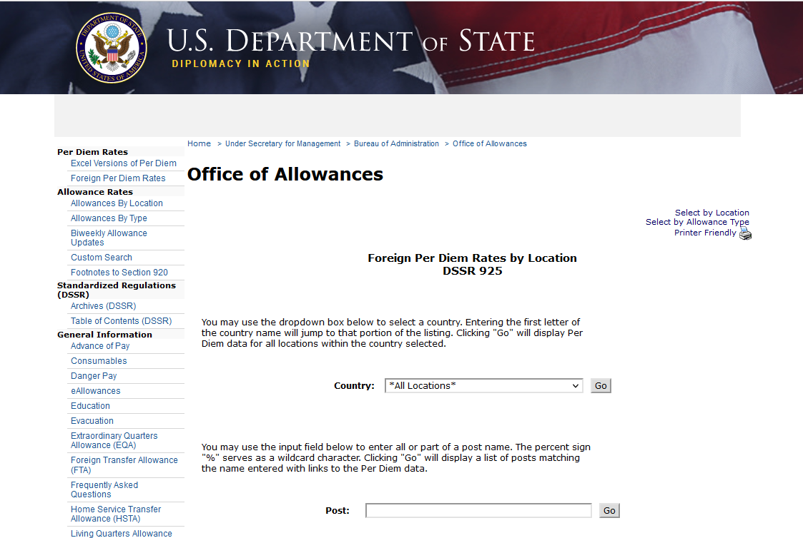

Summary
The summary page presents a recap of all expenses entered under transportation, lodging/food and fees/misc. As itemized expenses are entered under each category, they will display on the summary page and total at the bottom under “Total Reimbursement Amount”.
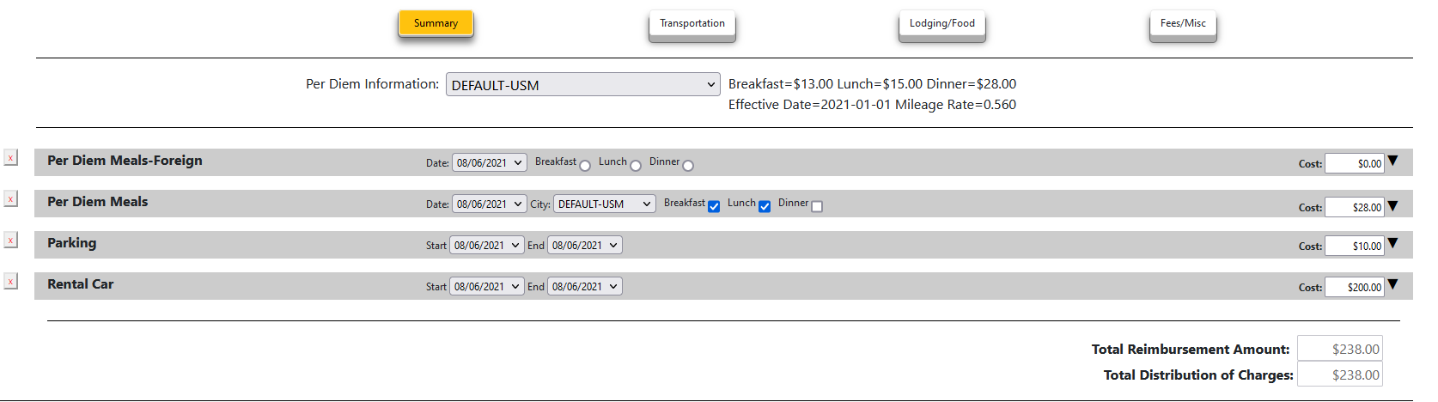

All expenses must be accounted for under a valid budget account combination (distribution of charges, also known as a chartstring) before the Reimbursement will move forward to DocuSign.

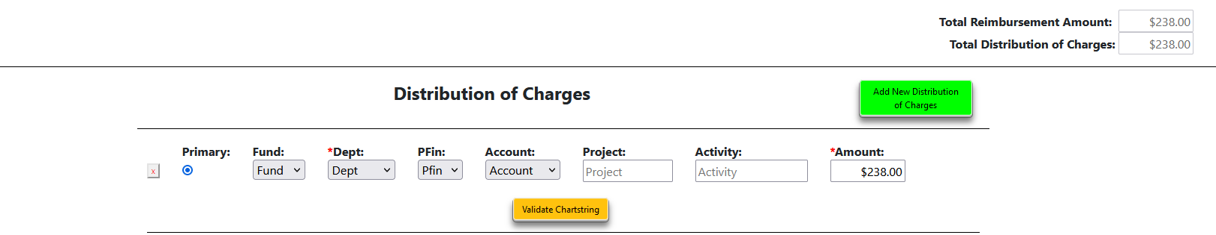
If Non-UMBC expenses are included, they will be deducted from the total amount of expenses to calculate the Total Reimbursement Amount and Total Distribution of Charges.

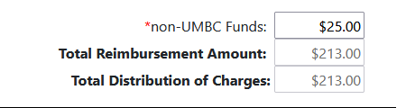

The Total Reimbursement Amount must be fully accounted for in the Total Distribution of Charges (using one department, or across multiple departments) before the reimbursement is submitted to DocuSign.

Adjust Distribution of Charges by must equal $0, by adjusting the value on the chartstring line(s), or adjusting estimated expenses. The text on this line will change to red when the funding sources are inadequate to satisfy the Total Reimbursement Amount.

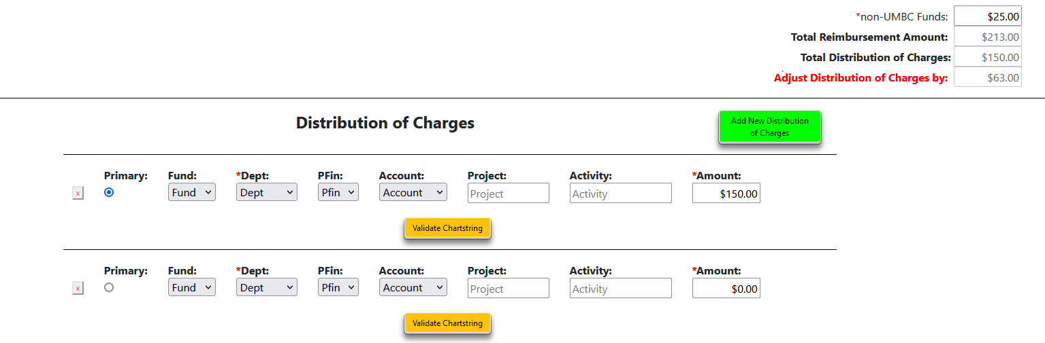

Distribution of Charges
Each chartstring has at least one “approver”, possibly a “second approver” if the department so chooses, and a “next higher authority” to approve international travel requests. Each approval level, for each department, must sign-off during the DocuSign process.

- Click “Add Distribution of Charges” to add multiple chartstring rows.
- Click the “x” to the left of the chartstring to remove a chartstring row.
- When there are multiple chartstrings, use the “Primary” button to select the primary account. Only ONE primary chartstring/account combination may be selected at any given time.

Each chartstring has an on demand “validate chartstring” button. Clicking this button will compare the selected account combination against valid PeopleSoft account combinations. Valid chartstring/account combinations are required before submitting to docusign for approvals.

Itinerary/Mileage

This category is found only in the reimbursement section. It is specific to those programs such as Choice programs, admission recruiters, etc. that have previously been given approval to provide separate car travel logs.

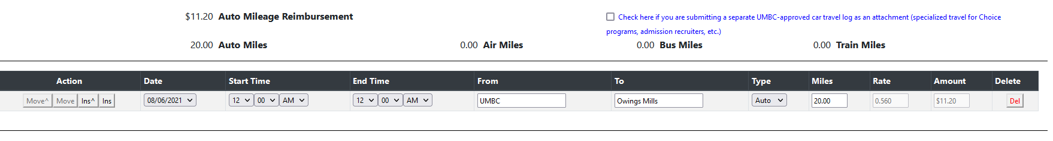

The reimbursement allows for the traveller to attach a separate car travel log as an upload or complete the log by adding lines on the reimbursement. The mileage rate will be automatically inserted and the total miles times rate will be calculated for you.

Documents
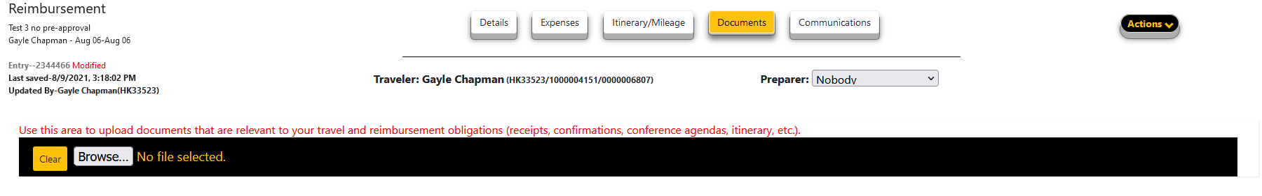
Use this section to upload documents that are relevant to your travel and reimbursement obligation (receipts, confirmations, conference agendas, itinerary, etc.). Again, be sure that your support documentation for the costs are legible and the dates and the amounts match.

Communications
This section is the same as in the Pre-Approval. (Link to Pre-Approval)

SUBMIT FOR REVIEW
When all mandatory fields are complete, the traveler/preparer may submit the Reimbursement request for “REVIEW”. This action will send an email message to ALL persons with the RB-REVIEWER role in the department to notify them that the Reimbursement has been submitted. (Only the Reviewer receives an email. If no RB-APPROVER is chosen, there will not be an email sent by the system.)
If the travel costs are shared among more than one department, the RB-REVIEWER(S) in the department designated as *primary* on the distribution of charges will receive the email message.

The status of the Travel Reimbursement will change from “Entry” to “Review”.

When the Travel Reimbursement Request has been submitted for Review, and is in “Review Status”, the traveler is limited to the following actions:

Changes to Reimbursement details may occur during review.

SUBMIT TO DOCUSIGN
The Reviewer may submit the Travel Reimbursement to DocuSign when the review is complete. At this point, no further changes can be made to the Travel Reimbursement details.

If no RM-REVIEWER is chosen for the department, the RM-APPROVER may submit to DocuSign.

After all of the signatures are completed, the Traveler and Approvers(s) will receive an email notification that the Reimbursement is complete. The status on the Reimbursement will change to “complete.”

State of Maryland Reimbursement/Payment
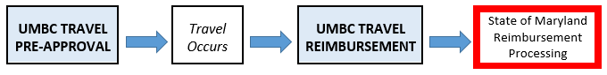
Once the Reimbursement has been approved and is complete, the Travel staff in Business Services will review your reimbursement request for accuracy and completeness. Please make sure that your documentation that has been uploaded in your reimbursement request is legible and the dates and amounts of the expenses match the reimbursement.

Please note that DocuSign will automatically create an RT ticket on behalf of the requester that will have the same ticket number as the Pre-Approval/Reimbursement ID. If the Travel staff have any questions, they will contact you through the RT ticket.

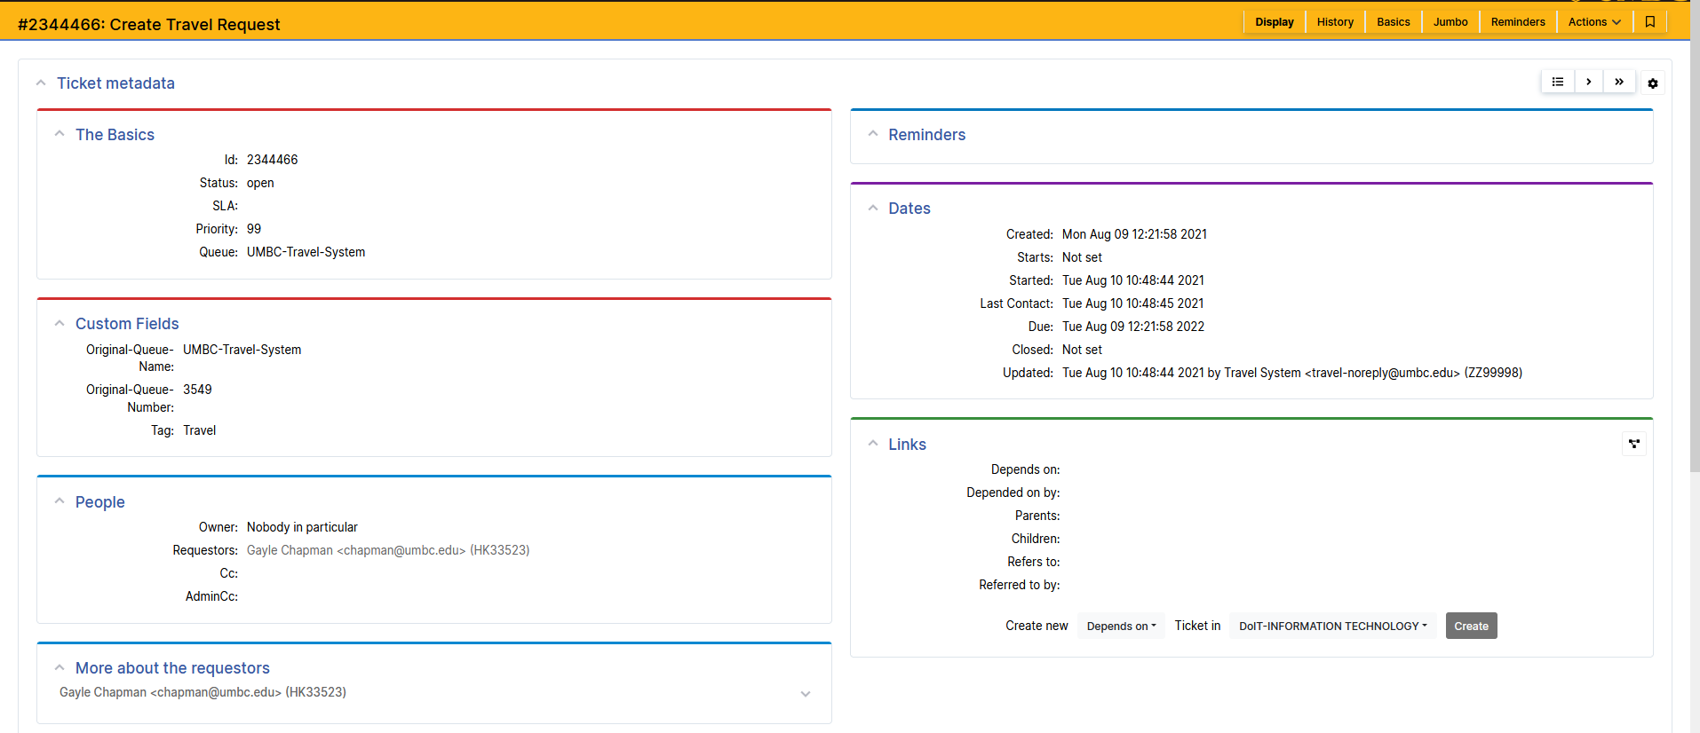

You can also communicate with the Travel staff through the RT ticket.

Once the Travel staff approves the reimbursement request, they will close the RT ticket and send the request for payment to the State of Maryland. It generally takes about 21 - 28 days for the State to process the payment.

For State of Maryland employees who have direct deposit for their paycheck, the reimbursement payment will also be deposited directly into their bank account. For non-UMBC employees or those without direct deposit, it will be mailed to the address on the reimbursement.

For questions regarding the reimbursement after the travel reimbursement RT has been closed, you can contact Business Services by requesting a RT ticket in the Travel queue.

https://businessservices.umbc.edu/travel/travel-inquiry/

Other questions you may have…

About Pre-Approval

What should I do if I am filling out a Pre-Approval for somebody that is not a UMBC employee?
Select the appropriate radio button to identify whether you are the traveler, or completing the travel request on behalf of an individual that has granted you permission to do so.

If you are completing this request on behalf of another traveler, that traveler must grant prior permission using their profile options. (See Travel System Profile Link). Select their name from the dropdown list. You will be listed as the preparer.

Where do I find submissions from myself/my department/other departments?
Those are found in the Main section of the Travel System. You can navigate to “My Submissions” or “Prepared on behalf of” or navigate to “Business Office” to view those submission assigned to yourself, your department or other departments if you are a Reviewer or Department Administrator. (Go to Travel System Roles)

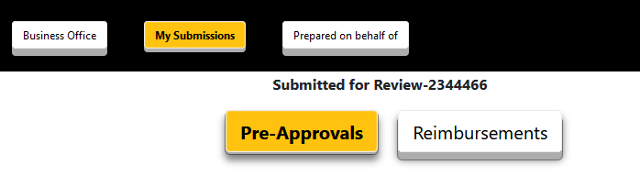
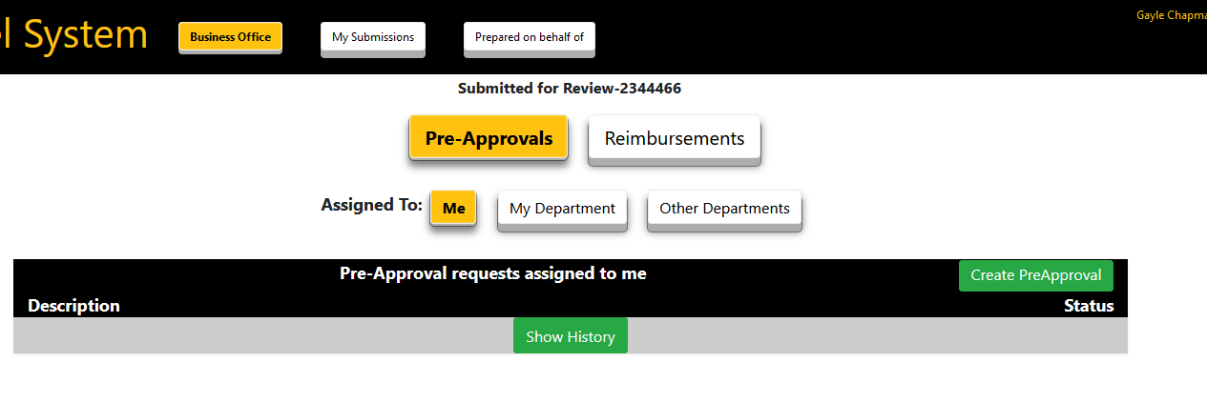

How do I designate individuals to submit/create/complete Pre-Approvals on my behalf?

In the Admin section of the dashboard, there are a number of buttons: Profile, Departments, People, Per Diems, Role Names and Status Codes.

Use the “profile” options to identify those individuals that are authorized to submit travel requests on your behalf. Enter the campus ID or Empl ID for the individual you choose to authorize on your behalf and click “add”. You can use the directory lookup to find the campus ID. A quick link to the directory is located in the upper right hand corner of the Travel System Screen.

How can I find the status of my reimbursement from the State of Maryland?

You can find out the status of your reimbursement by navigating to the Business Services website at: https://businessservices.umbc.edu/accounts-payable/

Then going to the AP FAQ menu on the top right and choosing “Tracking a Payment.” This will take you to the General Accounting Division of the State of Maryland where you can either log on to their query system or register as a new user and then log on.

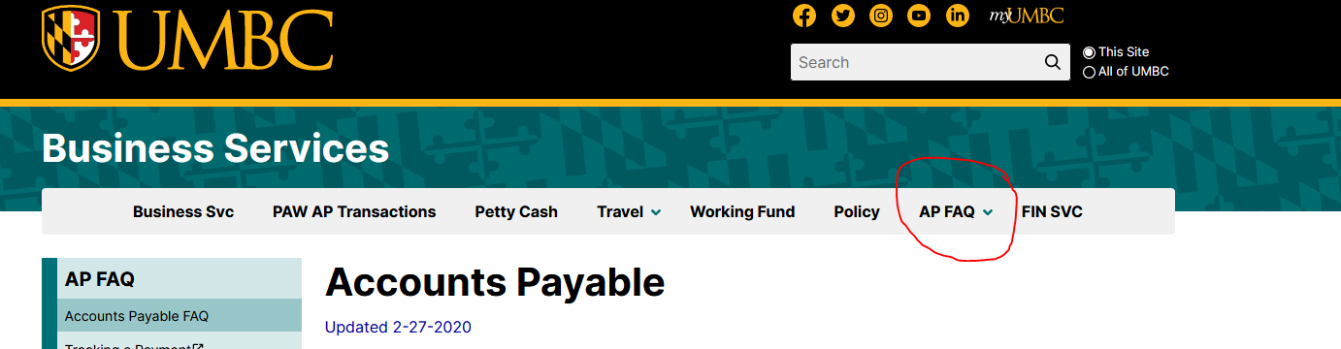

What should I do if I need a travel advance?
Obtaining a Working Fund travel advance should be a last resort as the Working Fund has limited funds available. For more information visit:

https://businessservices.umbc.edu/working-fund/

Status Codes
There are a number of Status Codes that are color coded that appear in the upper left corner of the Pre-Approval or Reimbursement that indicate the stage of completion.
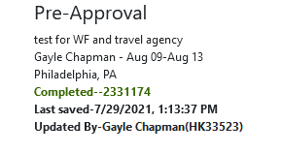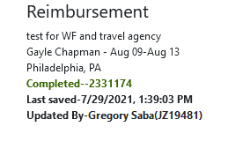

Review
A status of Review indicates the document has been submitted for review by the Traveler or the On Behalf Of individual to the business area for that department. Communication options back to the Traveler or the On Behalf Of individual will be used to satisfy any questions by the reviewer.

Submitted to DocuSign
Status of Submitted to DocuSign indicates the document has been submitted for approval (DocuSign) by the Primary Approver identified in the review process of the business area for that department.

Travel Approved
The Travel Pre-Approval process is considered Approved once the DocuSign process has finished. It will change to Completed once the Reimbursement process is initiated.

Processing
A status of Processing indicates the Travel Reimbursement document has been signed off by all roles in the DocuSign process and is now ready for manual steps required for PeopleSoft and the State of Maryland.

Cancelled
Travel Pre-Approval process can be set to Cancelled (Read-Only) if there is no Travel Reimbursement initiated. Travel Reimbursement process can be set to Cancelled (Read-Only) if workflow status is Entry, Review, or Approval Routing. If workflow status is Processing OR Completed then ONLY the System Administrator can update the status to Cancelled.

Completed
The Travel Pre-Approval process is considered Completed once the Travel Reimbursement process has been initiated. Please note the Travel Reimbursement process cannot begin before the first day of travel.

Travel Reimbursement is considered completed when the DocuSign process for Reimbursements has finished. Travel Reimbursement process is considered Completed (Read-Only) once acknowledgement that the State of Maryland has performed the EFT or mailed the check.

Completed*
The Travel Pre-Approval process is considered Completed* (Read-Only) when the travel occurs without a required Travel Pre-Approval. This entry is auto-created when the Travel Reimbursement process is initiated.

