OVERVIEW

The purpose of this document is to set forth supplier naming standards and best practices for maintaining suppliers in the supplier file. Naming standards will be used to provide a guideline for consistency and accuracy in the naming conventions for new suppliers. Improper or lax standards can cause significant degradation of the accuracy of information generated from the system, fines for improper tax reporting, and loss of control. The naming conventions discussed here make it easier for users to identify suppliers they want to use for transactions and reduce the number of duplicate suppliers.

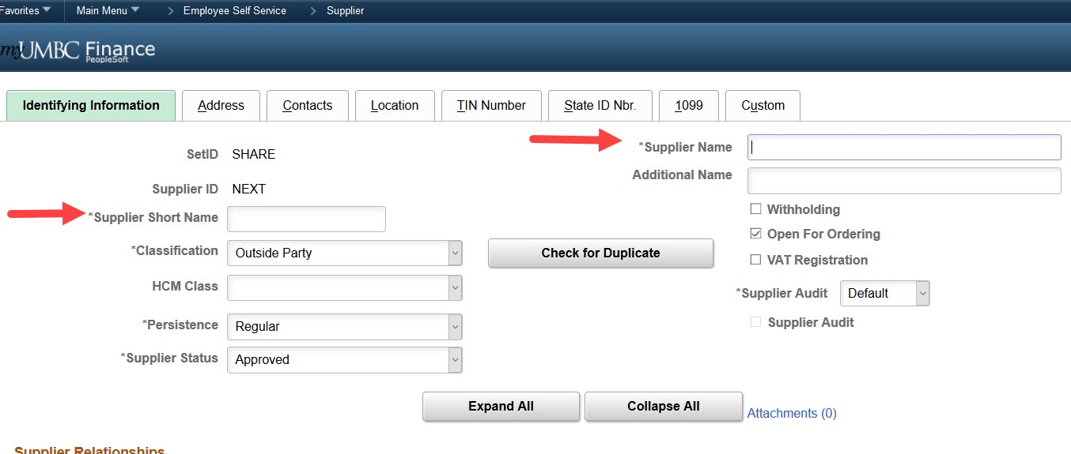
SUPPLIER SHORTNAME

The supplier shortname is entered into the system to uniquely identify a supplier for voucher and purchasing entries. Each supplier entered into the system will have its own supplier shortname which cannot be identical to another supplier shortname. The system utilizes a number extension to keep the shortname unique.

General Rules

- Do not use any spaces, punctuation or special characters.

- Enter up to the first ten (10) characters of the name. If the supplier name has 10 or more characters, the shortname should have 10 characters.

Examples

COMPANY/INDIVIDUAL SHORTNAME
CHARTWELLS CHARTWELLS
AJ STATIONERS AJSTATIONERS
EMJAY ENGR & CONTR CO EMJAYENGRC
KELLY JR,DON KELLYJRDON
ADAMS III,GEORGE B ADAMSIIIGE

- When the first word of a company’s name is “The” do not include it in the shortname.

- When the first words of a city supplier is “City of” include it in the shortname.

- When the first word of a supplier’s name is “University”, use the abbreviation UNIV followed by the additional letters as the shortname.

SUPPLIER NAME 1 STANDARDS

Individuals

- Enter the last name first followed by a comma, then the first name and middle initial(s).

- Do not use parentheses, apostrophes, or any other punctuation.

- Do no use degrees, military rank, or professional title.

- If the supplier has two last names or uses a hyphen between names, enter the first last name first followed by the second. Do not include the hyphen.

- If the vendor has two first names, enter the last name first followed by the first first name, then second first name

Examples

INDIVIDUAL SUPPLIER NAME
JOHN B. SMITH SMITH,JOHN B
LISA O’BRIEN OBRIEN,LISA
DR. MARY STONE STONE,MARY
MARY STONE, MD STONE,MARY
TOM WEAVER, JR WEAVER JR,TOM
GARY WAN II WAN II,GARY
LISA JENKINS-HOPKINS JENKINS HOPKINS,LISA
BOBBI JO BARNES BARNES,BOBBI JO

Businesses

As there is limited space in the supplier name fields, please try to abbreviate whenever suitable, however please avoid the use of punctuation and special characters, unless part of the name. A list of standard abbreviations is attached.

Examples

COMPANY SUPPLIER NAME
A & B CONSTRUCTION A AND B CONSTRUCTION
L R W CORPORATION LRW CORP
AMAZON.COM AMAZON.COM
UNIVERSITY OF GEORGIA UNIV OF GEORGIA
THOMAS LLC THOMAS LLC
INN @ ELLIS SQUARE INN AT ELLIS SQUARE
CITY OF BALTIMORE CITY OF BALTIMORE
PETE’S ON THE HILL PETES ON THE HILL
MCDONALD’S MCDONALDS

ADDRESS ENTRY
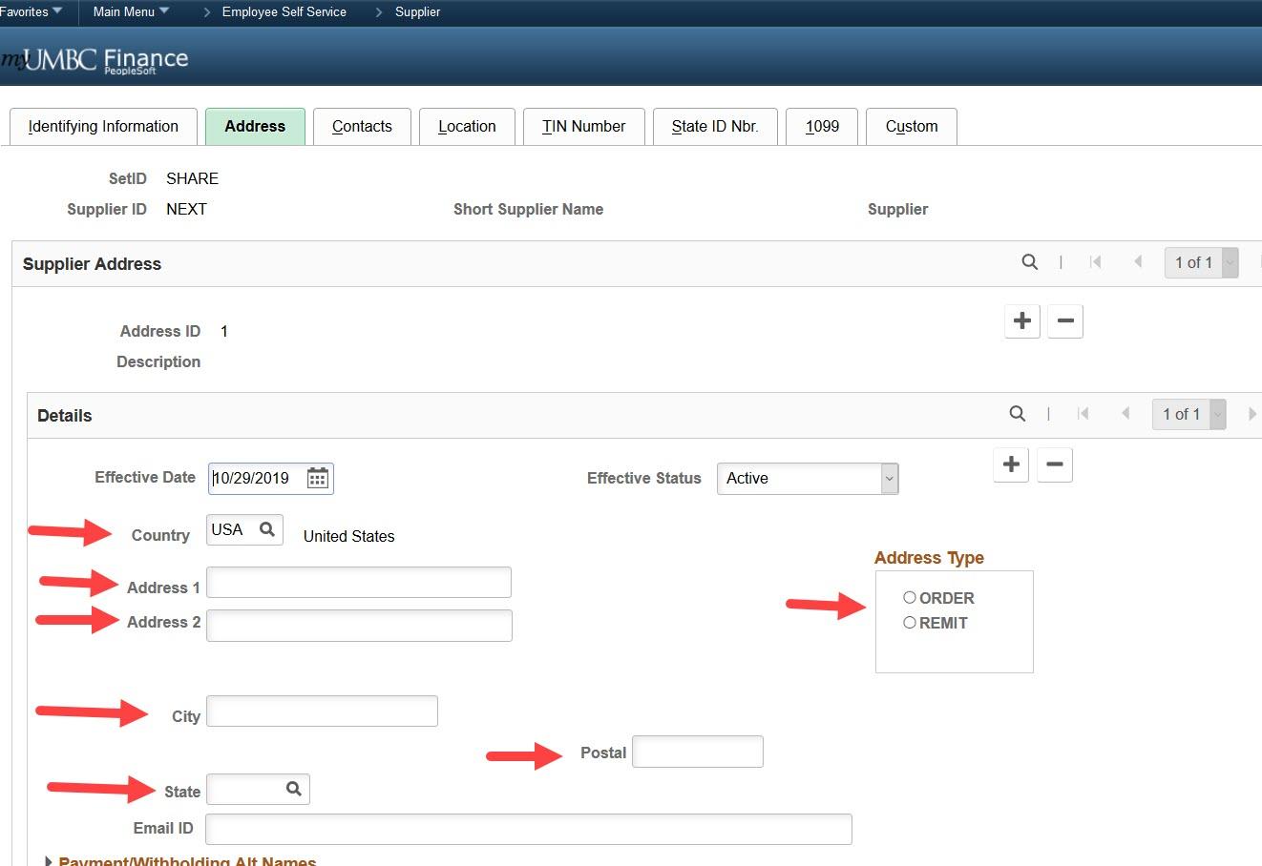

After selecting the address type:

- Address 1 should contain the street address. As space is limited, please abbreviate when suitable.

- Address 2 should contain apartment, suite or similar secondary information.

- All the fields highlighted are required.

- Enter Email ID, if known.

- For foreign suppliers, select Country code matching the actual country of the supplier and NOT OTH as previously instructed.

STANDARD ABBREVIATIONS

COMPLETE WORD | ABBREVIATION |  | COMPLETE WORD | ABBREVIATION
ADMINISTRATION | ADMIN |  | INSTITUTION | INST
AMERICAN | AMER |  | INTERNATIONAL | INTL
ASSISTANT | ASST |  | LIMITED | LTD
ASSOCIATE | ASSOC |  | MANAGEMENT | MGMT
ASSOCIATES | ASSOC |  | MANUFACTURING | MFG
ASSOCIATION | ASSN |  | NATIONAL | NATL
BUILDING | BLDG |  | PRESIDENT | PRES
CENTER | CTR |  | PUBLISHERS | PUBL
COLLEGE | COLL |  | PUBLISHING | PUBL
COMPANY | CO |  | REHABILITATION | REHAB
CONFERENCE | CONF |  | SECRETARY | SECY
CORPORATION | CORP |  | SERVICE | SVC
DEPARTMENT | DEPT |  | SERVICES | SVCS
DIVISION | DIV |  | SOCIETY | SOC
DOING BUSINESS AS | DBA |  | TRADING AS | TA
EDUCATION | EDUC |  | TREASURER | TREAS
EDUCATIONAL | EDUCL |  | UNITED STATES | US
GOVERNMENT | GOVT |  | UNIVERSITY | UNIV
INCORPORATED | INC |  | WAREHOUSE | WHSE
INFORMATION | INFO

ADDRESS ABBREVIATIONS

STREET IDENTIFIERS | ABBREVIATION |  | DIRECTIONALS | ABBREVIATION
AVENUE | AVE |  | NORTH | N
BOULEVARD | BLVD |  | SOUTH | S
CIRCLE | CIR |  | WEST | W
COURT | CT |  | EAST | E
DRIVE | DR |  | NORTHEAST | NE
EXPRESSWAY | EXPY |  | NORTHWEST | NW
FREEWAY | FWY |  | SOUTHEAST | SE
HARBOR | HBR |  | SOUTHWEST | SW
HARBOUR | HBR
HIGHWAY | HWY |  | BLDG UNIT | ABBREVIATION
ISLAND | IS |  | APARTMENT | APT
JUNCTION | JCT |  | BUILDING | BLDG
LANDING | LNDG |  | DEPARTMENT | DEPT
LANE | LNDG |  | FLOOR | FL
MOUONT | MT |  | MAIL STOP | MS
PARKWAY | PKWY |  | ROOM | RM
PLACE | PL |  | SECTION | SCT
PLAZA | PLZ |  | SUITE | STE
POINT | PT
ROAD | RD
SQUARE | SQ
STATION | STA
STREET | STA
TERRACE | TERR
TRAIL | TRL
TURNPIKE | TPKE

