Research Subject Incentive Payment Accounting Log

Procedures for Use

Purpose: Research Subject Incentive Payments are a common part of many protocols and an important tool employed by researchers in order to collect data. The Research Subject Incentive Payment Accounting Log is a tool provided to help a department administrator keep track of these payments in an organized way such that the accounting and reconciliation of the Internal Short Term Advance (ISTA) received from the working fund is organized, simple and intelligible.

# What makes up the tool?

The tool is made up of 11 sheets in a single workbook.

Study Summary Sheet: The first sheet (Far Left) is the summary and collects important information from all the individual study sheets. It provides a single location where you can see the status of each of the ISTA’s you’re administering in one place.

Study #1 – 10: All the other sheets are identical and can be used to record individual protocol financial activity in summary.

# Filling out the study sheets

The Study sheet is not a substitute or duplicate of the Research Incentive Payment Log.

The Research Incentive Payment Log is a record of each distribution made to each individual research subject which allows a cross reference and substantiation of the Receipt for Funds Disbursed (Receipts).

The Study sheet summarizes funds received and disbursed.

Funds received include checks from the Working Fund for the Protocol as well as expense reimbursements to the fund (e.g. bank fees charged to the PI account).

Disbursements are generally the sum total of all Receipts included on a given reconciliation, or bank fees charged to the PI’s bank account.

## Study sheet top section:

The top section of the sheet is the identifying information for the study. The information has two primary sources. The IRB and the approved Working Fund Check Request.

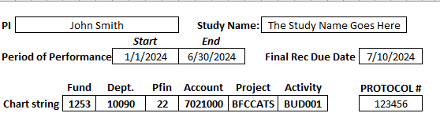

The Anticipated Protocol End Date as Listed in the IRB is the End Date Here

IRB

From Working Fund Check Request

## Competing transaction data:

The first line of your transaction data will usually most likely be to record the receipt of your ISTA from the working fund.

Type in your date of the check you have received under date. Use the dropdown list to select the transaction type.

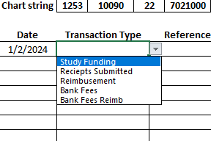

For a reference input your check number, and under received the amount of the check. For notes, notate if it’s a held in a bank account or in cash for future reference.

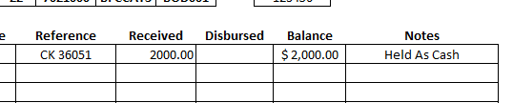

Your balance will automatically update to the available balance left to use in your protocol.

## Update the activity from your reconciliation

Every month you will prepare a reconciliation, transfer the information from the reconciliation to the accounting tool. The disbursed amount of $175 will be equal to the amount on line B of the current month’s reconciliation

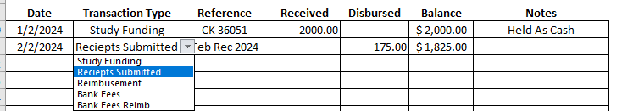

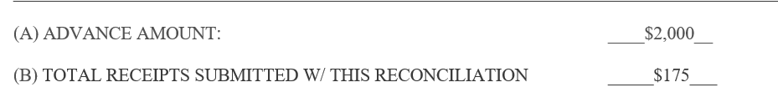

## Bank Fees

We are unable to process bank fees through the working fund due to GAD policy. In order to be reimbursed for these fees the PI will need to submit a reimbursement request with a copy of the bank statement showing the fees through PAW. After receipt of the reimbursement the PI should add the funds back to the Advance to make it whole.

When you select bank fee a reminder will appear in yellow at the bottom of the sheet reminding you to submit for reimbursement via PAW.

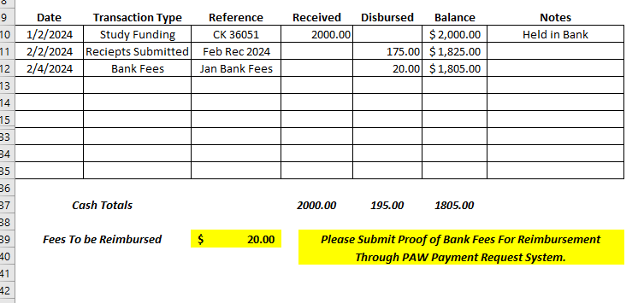

*This will help you complete the reconciliation as well as it will highlight the bank fee that will cause a variance in your reconciliation*.

***NOTE: On the summary sheet it will also highlight if bank fees need to be reimbursed.***

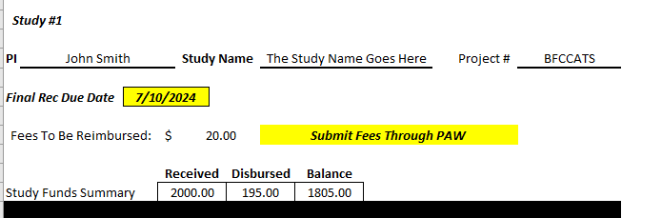

When the PI reimburses the fees to the advance fund show the reimbursement as received funds.

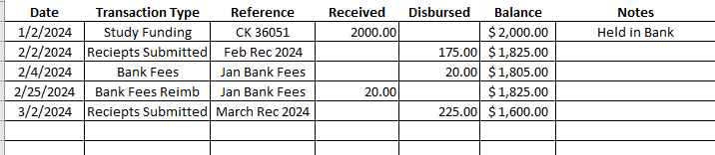

By consistently using the accounting tool you can maintain accurate records of the financial status of your advances and prepare reconciliations more efficiently.

Please forward comments or concerns to business services.