Working Fund

Internal Short Term Advance Procedures

Research Study Incentive Payment – Advance

Purpose: This procedure provides specific direction as to the documents and process required to be followed by Principal Investigators (PIs) and or their delegates when requesting and administering an internal short term advance (ISTA) for the purposes of facilitating Research Study Incentive Payments.

Contents

Application: 1

IRB Approval 2

Check Request Form 2

Period of Performance 2

Full Chart String 2

Department Business Administrator 3

Advance Agreement 3

Administration of the Advance 3

Advance Custody 3

Bank Account Requirements 3

Held As Cash 4

Disbursing Funds 4

Reconciliations 5

Completing the Reconciliation 6

Certification 7

Departmental Accounting Records – Not Research Subject Sensitive 7

Requesting Additional Funding 7

Extention Process 8

Funds Recall 9

# Application:

The application packet for an ISTA consists of three documents:

* Evidence of [Institutional Review Board](https://research.umbc.edu/institutional-review-board-human-subjects/) (IRB) approval.
* Check Request form (Appendix A)
* Fully executed Advance Agreement (Appendix B)

## IRB Approval

To receive IRB approval please contact the division of Research and Creative Achievement, [Office of Research Protections and Compliance](https://research.umbc.edu/office-of-research-protections-and-compliance/) (ORPC). The ORPC staff can assist you in completing the required process to have your research protocol approved by the IRB.

## Check Request Form

After you have received approval for the protocol from the IRB, complete a [check request form](https://umbc.box.com/s/78ziggwt6cb952fo1noy338i3nztznuh) and submit it to the working fund custodian for review and approval.

The check request form is a DocuSign process which will require the PI to have identified:

* The period of performance for the Protocol
* The full chart string for your protocol including your PeopleSoft Project Number. If you need to establish a new PeopleSoft Project Number, please complete the [Project Request Form.](https://financialservices.umbc.edu/project-request/)
* The Department Business Administrator who will be assisting with the administration and accounting of the Advance.
* The approving authority

### Period of Performance

The period of performance is used to assist in establishing the term of the advance. The term of the advance is established by the Working Fund Custodian. Generally, the advance will be due 10 days after the end of the period of performance. For protocols which have a period of performance greater than one year, the due date will be one year after the approval of the check request.

For protocols which require funds for a period greater than one year, the current ISTA will be closed and a new ISTA will be established by rolling funds over to a new advance.

The process for rolling over the expiring Advance to a new Advance will require two steps.

* Receipt of final reconciliation, within the due date established in the original Advance Agreement.
* Receipt of final receipts in support of the final reconciliation within the due date established in the Original Advance Agreement.
* Extension Agreement executed by the PI

### Full Chart String

The PI should work with their approving authority and business administrator to determine the appropriate chart string. In the event you need to establish a new PeopleSoft project number for your protocol please complete the Financial Services [Project Request Form](https://financialservices.umbc.edu/project-request/) DocuSign process.

### Department Business Administrator

The Department Business Administrator (DBA) is a critical part of the team when administering the advance. In reviewing your check request, the Working Fund Custodian will contact (if unknown) your (DBA) to determine their experience with administering/accounting for the Advance.

DBA’s without experience will be required to take a brief training on ISTA administration, provided by the Working Fund Custodian or other Business Services personnel. This training must be completed prior to the disbursement of the Advance.

## Advance Agreement

After review and approval of the IRB and Check Request Form, the Working Fund Custodian will send the PI an Advance Agreement completed with all relevant information based on your protocol.

Please read the advance agreement to ensure you understand all the terms and conditions of the advance, then DocuSign the Advance Agreement.

The Advance Agreement is made between the PI, referred to as the "Advance Holder" (identified by name and email), and the University of Maryland, Baltimore County (UMBC). The purpose of this agreement is to outline the terms and conditions regarding a cash advance provided by UMBC for work to be conducted under the PI’s IRB Protocol.

The key points covered in this agreement include:

* The Advance Holder's responsibility for safeguarding and repaying the advance.
* The due date for repayment and the conditions under which it may be extended.
* Restrictions on holding funds in a checking account.
* Requirements for submission of monthly bank statements and reconciliation forms.
* Procedures for disbursement of funds to study participants and submission of receipts.
* Liability for lost or stolen funds and procedures for reporting theft.
* Consequences for non-compliance with the agreement, including recall of the advance and potential payroll deductions or collection actions.
* The Advance Holder's acknowledgment of these terms through signature.

# Administration of the Advance

## Advance Custody

The Advance can be deposited in a bank account or held as cash.

### Bank Account Requirements

If depositing the funds into a bank account, the following restrictions must be observed.

1. The account **may not** bear interest.
2. The funds **may not** be co-mingled with personal funds.
3. The account **must** be in the PI’s name (**not UMBC).**
4. **No** bank account fees may be reimbursed from these funds.

1. If it is appropriate to charge such fees to the grant, a Payment Request Form should be submitted through the PAW procurement system and the reimbursement must be used to reimburse the advance.
2. A copy of the bank statement showing debits for fees must be attached to the payment request.
   * + 1. If deposited in a joint account, the Advance Holder remains solely responsible for the repayment of the entire advance. Joint bank accounts are not recommended.

### Held As Cash

Holding funds as cash is convenient but also introduces the risk of theft or loss. In either case the Advance Holder is solely responsible for missing funds.

Cash should:

Never leave campus, unless traveling to a site to conduct activities directly associated with the Protocol.

Kept in a secure/locked location with limited access.

## Disbursing Funds

Funds may only be disbursed by individuals expressly authorized by the IRB. When disbursing funds, the Receipt for Funds Disbursed (Receipt) (Appendix C) must be completed.

The Receipt is a critical document that captures important information necessary for the accurate accounting of the Advance. Including:

* PeopleSoft Project # - Used to cross reference with accounting financial records.
* IRB Protocol # - Used to validate the funds used as authorized by the IRB approved Protocol.
* Participant ID # - For purposes of participant privacy, the Receipt does not contain the Participant name rather it only references the Participant ID Number.
* Interviewer Name and Signature - Used to verify that the distributing party was authorized by cross reference to the IRB.

The Receipt should be maintained in the Protocol files of the PI.

A copy of each receipt will be submitted to the Working Fund Custodian with the Monthly Reconciliation as substantiation of expenditures made.

The information as collected on the Receipt will be used to complete the Research Subject Incentive Payment Log (the Log), as required by the IRB. The Log is maintained by the PI and is confidential. It can only be reviewed by authorized individuals, in order to ensure the proper conduct of the approved protocol and proper fiscal procedures are being followed.

The receipt and log should include much of the same information and should be easy to cross reference by date, participant ID # and amount.

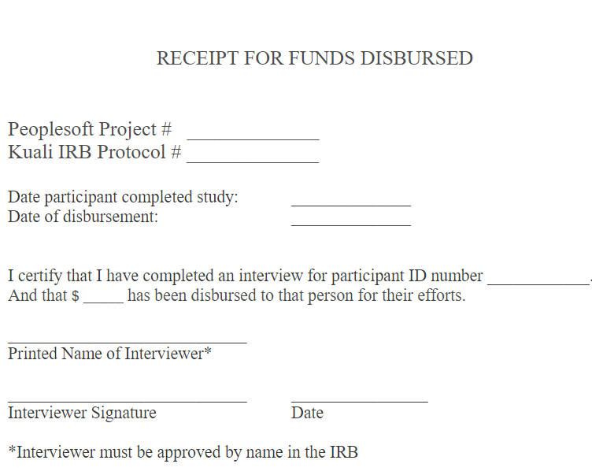

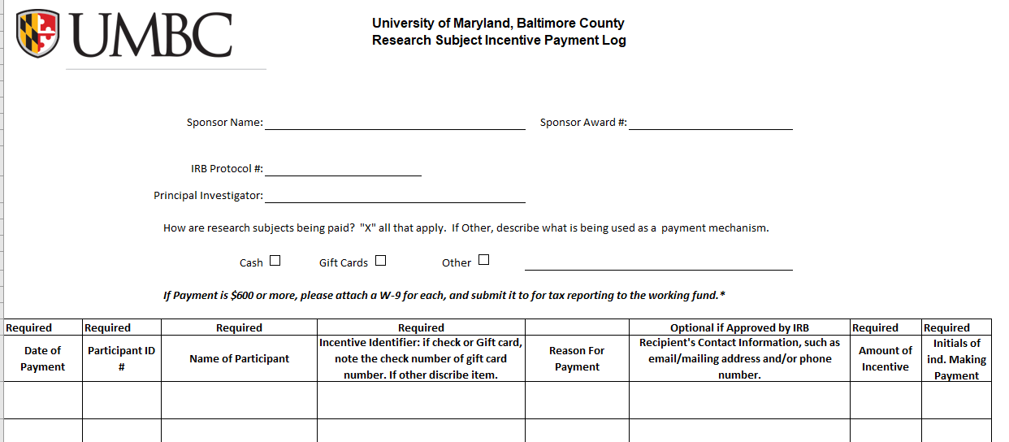

There is additional information collected on the Log which is necessary to substantiate the validity of all payments. This information will only be accessible by individuals authorized to review the protocol by the IRB or by Financial Services, USM internal Audit or the Office of Legislative Auditors when conducting financial audits. Although the identity of participants is protected, one cannot guarantee that an individual’s identify will always be anonymous. PI’s should consider this when designing the informed consent.

Personally identifiable information (PII) is any information connected to a specific individual that can be used to uncover that individual's identity. PII is not maintained on the receipt, however it is maintained on the Log to substantiate the validity of payments. Maintaining the security and confidentiality of the Log is essential to conducting the Protocol ethically.

For more information on maintaining your Research Subject Incentive Payment Log please refer to the IRB protocol or contact the [Office of Research Protections and Compliance (ORPC)](https://research.umbc.edu/office-of-research-protections-and-compliance/).

[Click here](https://umbc.box.com/s/llg3weg9vwiefuncquyopieqxvtnvsjd) for an ORPC approved Research Subject Incentive Payment Log which you can use to maintain records of the payments made for your protocol.

# Reconciliations

Each month a Research Subject Incentive Payment Advance Reconciliation of Funds (Appendix D) (the Reconciliation) must be submitted to the Working Fund Custodian. Receipts for funds disbursed during the preceding month as well as a copy of the current month bank statement (if applicable) must also be submitted.

Failure to submit the Reconciliation may result in the Advance being recalled by the Working Fund Custodian.

## 

## Completing the Reconciliation

Top Section - Complete with the following information.

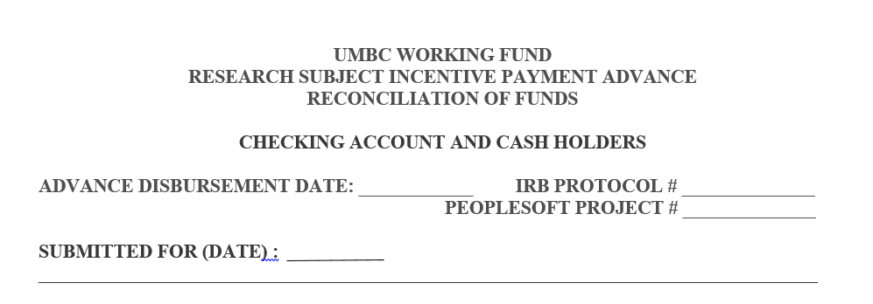

Month End Date for the Period being reconciled.

Check Date – of Check Received From the Working Fund Custodian to Fund the Advance

Reconciliation Section:

1. 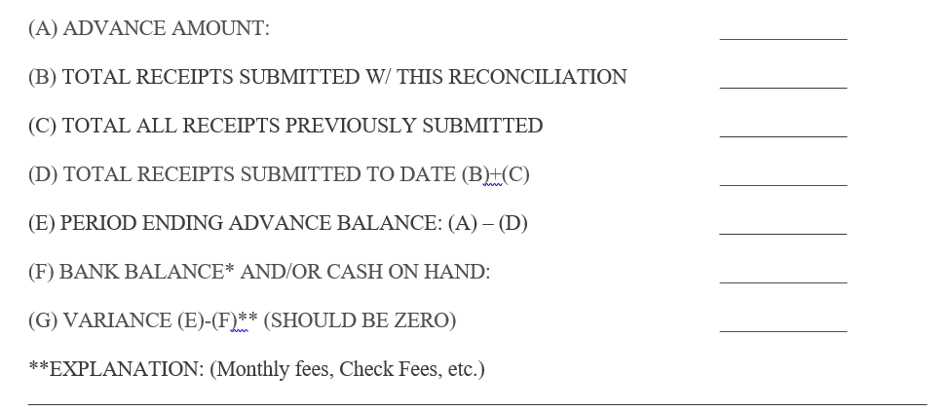Advance Amount: Should be equal to the advance amount as referenced on the Advance agreement.
2. Should be equal to all receipts being submitted with this reconciliation. As discussed above, on a monthly basis the PI must ensure that all receipts for funds disbursed during that month are submitted as substantiation for payments to the working fund. The total of all attached receipts are entered here.
3. Should be equal to all receipts previously reported on line (B) in past reconciliations. For example if last month’s reconciliation shows $50 on line (B) and $150 on line (C), this month line (C) would be equal to $200 ($50+$150).
4. This line simply sums line (B) and (C) and shows the total of all receipts issued by the PI to date.
5. The period end advance amount is showing how much should be left for the PI to use to complete the Protocol. The calculation is (A) – (D), or total Advance Amount less all amounts disbursed to Research Subjects to date.
6. Current Balance: This amount will come from one of two places:
   1. Bank Statement: If the PI is holding funds in a bank account the bank statement should be submitted, to substantiate the balance remaining.
   2. Cash on Hand: If the PI is holding funds as Cash, they should count all cash on hand for this protocol and enter total cash here.
7. Variance- This amount is a calculation which starts with Period Ending Advance Balance and subtracts the Bank Balance or Cash On Hand balance. The variance should always be zero. Any variance should be explained below (G) in the Explanation section.

## 

## Certification

The certification section of the Reconciliation must be completed by the PI and may be completed by a Business Manager if the Business Manager completed or participated in the preparation of the Reconciliation. The Business Manager should be the same individuals identified on the Check Request as the Department Business Administrator.

The certification of the Reconciliation by the PI documents that the PI has reviewed all the receipts, bank statements, and any other documentation submitted and has verified that they are all valid and that all protocol interviews and payments comply with the IRB. It also verifies that no receipts were previously submitted.

Reconciliations without the PI’s signature will be returned as incomplete.

If the Working Fund Custodian has questions regarding the reconciliation, we will we contact the Business Manager

## Departmental Accounting Records – Not Research Subject Sensitive

As a Department Business Administrator it is important to maintain records of the financial transactions. Business Services has developed a [Research Subject Incentive Payment Accounting Log](https://umbc.app.box.com/file/1349416939193?s=g117rxh3zueksmgdrskbvyb5yqvrjq4t) which we invite you to download and use in order to track one or as many as ten Advances.

The Accounting Log includes a Summary Sheet which allows you to see a snapshot of the status of each of your advances in one place.

# Requesting Additional Funding

It may be necessary to request additional funding in order to conduct your research. In this event the first requirement is that the additional funding is allowable under the terms of your IRB. If the IRB’s funding threshold has been met, then an amendment to your IRB will need to be made prior to requesting additional funding from the Working Fund.

In the event that the total funding under your IRB had not been met or exceeded you may request an addition funding by sending a brief email to the working fund custodian ([marshaj@umbc.edu](mailto:marshaj@umbc.edu)). Which contains the following.

* PI Name:
* Project #
* Protocol #
* Amount being requested

The Custodian will cross reference you information with the IRB and forward an Advance Agreement Addendum (Exhibit C) to the PI by DocuSign. Upon receipt of the executed agreement the Custodian will issue the additional funding up to the amount allowed by the IRB.

When the additional funding is ready for pick up the Custodian will contact the individual as shown on the original check request. In the event contact information has changed please include this in your email request.

# Extension Process

At the expiration of an advance period, the initial advance must be closed out and a new advance will be established for the extension.

The purpose of this process is to ensure that in no event will any advance be extended that is not reconciled and maintained in accordance with the terms and conditions of the Advance Agreement.

To extend the advance past the original expiration date, the following process should be followed:

1. Submit the final monthly reconciliation in good order, with all required documentation to the Working Fund Custodian.
2. Return any funds no longer needed for the protocol.
3. With the reconciliation and the supporting documentation submit a request to extend your advance include the following in your email:
   * PI Name:
   * Project #
   * Protocol #
   * Requested Extension (date in the future)
   * Dollar amount retained in anticipation of extension.

Upon receipt the Custodian will review the request. Any concerns will be brought to the Manager of Business Services for review.

Note:

* Advances may not be transferred between protocols.
* Utilization of funds will be evaluated, if funds are not actively being utilized the Custodian may ask for additional information to support the necessity of the extension.

Upon approval the Custodian will forward to the PI the Advance Agreement Addendum (Exhibit C) By DocuSign.

# Funds Recall

In the event that funds are recalled to the working fund the PI should return the funds, a final reconciliation and supporting documentation as soon as possible and no later than 30 days after the date of initial recall.

If funds are not returned within thirty days a second recall request will be issued. If funds are not returned within thirty days of the second recall request the Custodian will proceed as follows:

**Faculty/Staff:** Notification of payroll deduction will be provided as well as the anticipated date of payroll deduction. The amount of payroll deduction will be determined by the most recent advance balance shown on the final reconciliation which was submitted in good order. Payroll deductions will be processed on the second payroll following notice of payroll deduction, unless an employee will be receiving their final payroll imminently.

Faculty/Staff who submit the working fund documentation and remaining advance prior to the payroll deduction may avoid the payroll deduction if documentation is turned in no later than the five days prior to the planned payroll deduction.

In the event that funds are not received by the Working Fund the obligation may be submitted to the State of Maryland Central Collections Unit (CCU).

**Students:** 30 day notice of intent to transfer the obligation to the students University account will be given.

After 30 days the obligation will be submitted to Student Business Services and may impact the Students good financial standing with the University. Students who are not in good standing may not have access to their official transcript, diploma, and may incur financial penalties. See more on impacts of the [loss of good standing status here](https://financialsmarts.umbc.edu/learn/managing-my-student-financial-account/).

Student debts with the University may be submitted to the State of Maryland Central Collection Unit.